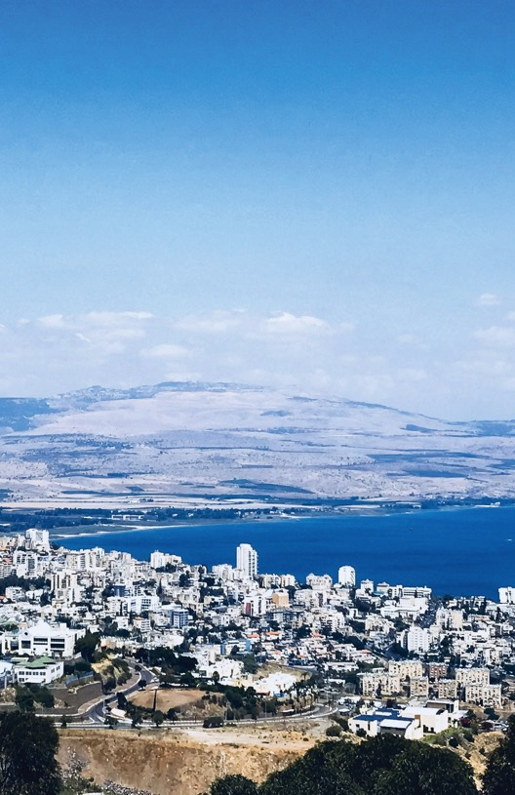
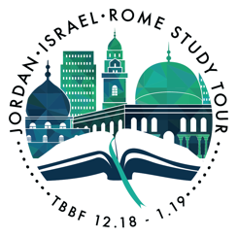

NAME

LEBANON

Tel Hazor Natl Park 7 Mount of Beatitudes 6 The Galilee Boat 6
Magdala 6
Mount Carmel 8
Nazareth 8

Megiddo 8

Ceasarea 8

Tel Dan Nature Reserve 7
Banias (Panias) Fall 7

Golan Heights 7

Capernaum 6
Church of the Primacy of Saint Peter 6
Tiberias 5

SYRIA
Beit She’an 5

JORDAN

Amman 2

The Baptismal Site of Jesus Christ 4
Jerusalem Qumran 12
8-11,13
Bethlehem 9

Ein Gedi 12

Masada 12

Mt Nebo 5
Church of Saint George 5
Dead Sea Spa Hotel 4

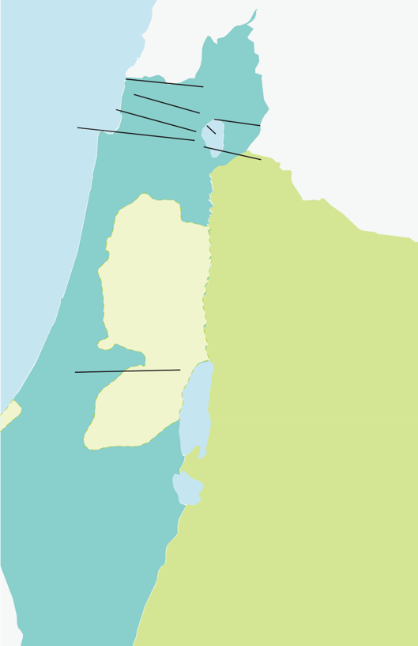
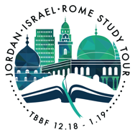

ISRAEL

Petra 3

Table of Contents

Itinerary

Site Posts by Day:
Day 2 3
Day 3 7
Day 4 11
Day 5 15
Day 6 21
Day 7 29
Day 8 37
Day 9 45
Day 10 53
Day 11 61
Day 12 67
Day 13 75
Rome Map 85
Day 14 87
Day 15 91
Day 16 97
Worship Lyrics (Alphabetical Order) 102
Hotel Contact Information 131
Emergency Contact Info 133
Roster 134

Itinerary

Wed 12/27 #1

Depart USA
Mon 12/31 #6 | Tues 1/1 #7 | Wed 1/2 #8
Church of the Beatitudes, | Hazor, Tell Dan, Ceasarea | Nazareth, Megiddo, Mt.
Peter’s Primacy, Caper- | Philippi, Golan Heights, | Carmel, Ceasarea Martima,
naum, Khorazim, Jesus | Bethsaida | Jerusalem
Boat Museum, Boat Ride,  Magdala | Overnight in Tiberias | Overnight in Jerusalem
Overnight in Tiberias
Mon 1/7 #13 | Tues 1/8 #14 | Wed 1/9 #15
Upper Room, House of Caiaphas, Ch of All | Flight Home or Flight to Rome | Trajan’s Column, Via dei Fori Imperiali, Mamertine
Nations, Garden of Geth-  semane, Kidron Valley, Via Dolorosa Judgment Hall, Ch Holy Sepulcher, Garden Tomb, Communion  Overnight in Jerusalem | Ostia Antica, Church of Santa Prisca, Aventino Hill, Insula Di San Paolo alla Regola  Check into our hotel in Rome | Prison, Capitoline Hill,  Piaza del Campidoglio, Roman Forum Palatine Hill, Imperial Palaces, Arch of Constantine, Colosse- um, Catacombs of Santa Domitilla

Thurs 12/27 #2 | Fri 12/28 #3 | Sat 12/29 #4 | Sun 12/30 #5
Arrive Amman, | Petra, Wadi Musa | Bethany Beyond | Madaba, Mt. Nebo,
Jordan  Transfer to hotel. | Arrive El-Ji Post, Siq & Treasury Dinner and | the Jordan,  Baptisms in Jordan River, Dead Sea Spa | Border Crossing,  Bet She’an, The Galilee  Overnight in
 | overnight in | Dinner and | Tiberias
 | Petra. | overnight at
 |  | The Dead Sea
 |  | Spa
Thurs 1/3 #9 | Fri 1/4 #10 | Sat 1/5 #11 | Fri 1/6 #12
Mount of Olives, | Western Wall, Rab- | Temple Mount, | Masada, Ein Gedi,
Southern Steps, | binical Tunnel, St. | City of David, Elah | Qumran, Tel Jeri-
Bethlehem Church | Anne’s Church and | Valley, half day of | cho, Wadi Qelt
of the Nativity,  Shepherd’s Fields  Overnight in Jerusalem | Pool of Bethesda,  Model of Jerusa- lem, Shrine of the Book, Israel Arche- ology Museum | leisure  Overnight in Jerusalem | Overnight in Jerusalem
Thurs 1/10 #16 | Fri 1/11 #17
Basilica of St John | Flight Home
in Lateran, Holy
Steps, Trevi Foun-
tain, Pantheon,
Navona Square,
Vatican Museums,
Sistine Chapel

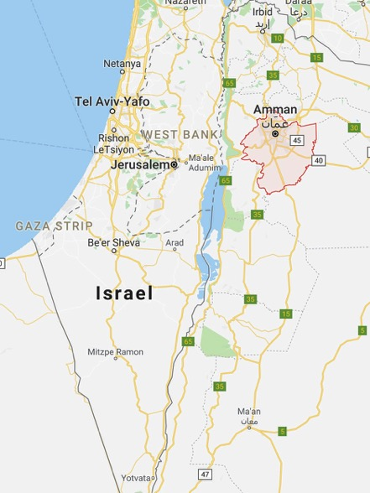

Day 2 Arriving in Amman, Jordan
elcome to Amman, Jordan, and the first official day of our tour! What will we be seeing here in Amman? Not much, unfortu-
W
nately. It’s merely our overnight stopping point before a long bus ride on the King’s Highway, to Petra!
But is there any historical significance to Amman, the capital city of Jordan? Yes there is! The biblical name for the city of Amman was Rabbath-Ammon, the only city of the Ammonites mentioned in the Bible. It was mentioned as having an extraordinary piece of furniture in Deuteronomy 3:11.
The city was a key location for one of the most infamous stories in the Bible, located 20 miles east of the Jordan River. In 2 Samuel 10-12 we read all about the connection between King David and this city. One of these connections involves David’s most egregious sin, his affair with Bathsheba and the murder of her husband Uriah. David’s life and the life of his family was never the same. So, this ancient city of Rabbah or Amman, is the place of the worst event of King David’s life.
Later, after God had confronted David for his sin, and David repented, we find out that he conquered the city of Rabbah (2 Samuel 12:26-31)
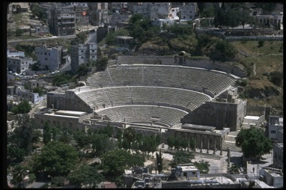

In OT times the city was known as Rabbah of the Ammonites.

“Although Amman was not inhabited during the Persian period, this changed under the Greeks, who Hellenized the city and changed
its name to Philadelphia. Under Roman control, Amman became a member city of the Decapolis, a confederation of ten Hellenistic cities east of the Jordan. The city remained a part of the Roman province of Arabia until its conquest by the Muslims, who renamed it Amman.
The material remains in the lower city include a well-preserved the- ater, an odium, and a nymphaeum, as well as a street and several Roman tombs… Remains of public buildings and holy places are located on the Citadel Hill.” (from Lexham Bible Dictionary)
“In the Hellenistic period the city was renamed Philadelphia to honor Ptolemy II Philadelphos, the Hellenistic ruler of Egypt (285–247 B.C..). In 218 B.C.. it was captured by Antiochus III the Great, the Hellenistic ruler of Syria. For about a century before the Roman conquest of
the Near East, Amman belonged to the Nabataeans. When Pompey conquered Syria and Palestine (ca. 63 B.C.), Philadelphia became the southernmost member of the Decapolis. In 106 A.D.., it became a city in the Roman province of Arabia. Situated on the magnificent Via Nova Traiana which joined Bosra with the Red Sea, Philadelphia en- joyed a long period of prosperity during the 2nd century A.D.” (from Anchor Yale Bible Dictionary)
Although we won’t really have the opportunity to see much in Amman, it is the first place we will see with our own eyes – that which God wrote about in His Word. We’re not in the “Promised Land”
yet! We’re located on the other side of the Jordan River. But we’re still walking on ground that was walked on by David’s men, and possibly even King David himself.
What are we already starting to experience here? The Bible is true. The people and places in it are real people and real places. This is just the beginning of the sights, smells and tastes of sort of a journey back in time.

Biblical References
2 Sam 10-12 - David’s dealing with the king of Ammon and his son; David’s sin with Bathsheba & Uriah; David & Joab conquer the city of Rabbah.
Amos 1:13ff; Jeremiah 49:2ff - God’s judgment proclaimed against Rabbah

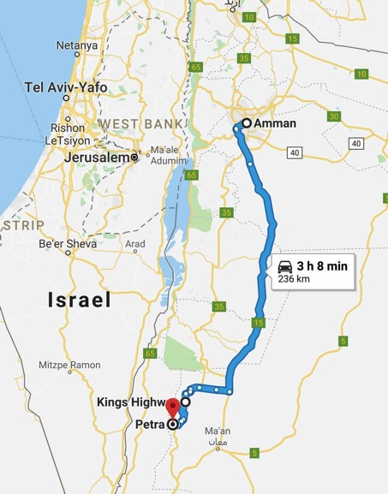

Day 3 – Journey to Petra
fter breakfast we will be leaving Amman on a few hours bus ride. We will be visiting one of the “7 Wonders of the Modern
A
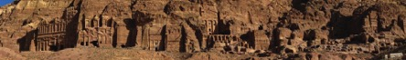
World.” It’s the ancient city of Petra. The city is an ancient Edomite and Nabatean capital. The Bible refers to this area as “Sela.” and it is locat- ed about 170 miles south of Amman, 50 miles south of the Dead Sea. Aptly named, much of the city is carved into sandstone cliffs.

Way of the Kings
In 2 Kings 14:7 and 2 Chronicles 25:5-16 the story is told of King Amaziah’s victory over the Edomites and the city of Sela. This took place around 800 B.C.. It’s a sad story of one of the kings of Judah who followed the Lord, but not with his whole heart, often relying on himself. Ultimately, this led to his downfall. We’ll talk more about this biblical story “on location.”
About 200 years later the Edomites helped Nebuchadnezzar, king of the Babylonians, and rejoiced over his destruction of Jerusalem in 586 B.C.. The Edomites seemed so secure and invincible, with their high and rugged mountains and fortresses of rock. But Jeremiah prophe- sied about their ultimate judgment from the Lord in Jeremiah 49:16-
18. As we visit Petra we will see firsthand the remains of a location where God’s Word stands fulfilled against a people that stood in defi- ance against Him. I think it will be surreal!
An Arab people called the Nabateans eventually inhabited the city, even until Roman times. When the Romans annexed the city, around 106 AD, its final downfall was under way. At one time it was estimated that 30,000 people lived in this protected canyon. But now only tour- ists and local vendors visit the ancient ruins.
The ancient city of Petra (Greek for “rock”) is located in the Jordanian state of Ma’an and is known for its rock cut architecture and elaborate water conduits system. Evidence shows that the earliest settlements here date back to 1550 B.C. when this site is listed in Egyptian military

campaign accounts, as well as the Amarna letters. In these documents it was known as Pel, Sela, or Seir. The site is mentioned in the Bible
in 2 Kings 14:7. It is also described as one of the places the descen- dants of Esau (Edom) inhabited, and is the focus of the prophecy of Obadiah.
In the 6th century B.C. the city became the capital city of the Nabataeans, an ancient people group that lived in southern Jordan, Canaan, and Arabia. It lies on the slope of Mount Hor, also known as Mount Sela. Pliny the Elder and other ancient writers identify Petra as a great city, and the center of the Nabatean caravan trade. Enclosed by towering rocks and watered by a perennial stream, Petra not only was a strong fortress, but also controlled the main commercial routes which passed through it to Gaza in the west, Bosra and Damascus in the North, and to the Persian Gulf to the south.
Excavations have concluded that it was the ability of the Nabateans to control the water supply that led to the rise of the desert city that became known as an artificial oasis. Though often in the center of flash floods, the Nabateans controlled these floods using an elaborate system of dams, cisterns, and water channels. They were able to store water for long periods of drought, and even prospered through the sale of water.
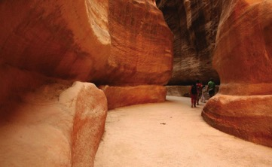
Most visitors approach Petra from the east through a dark, narrow gorge known as the Siq (“shaft”). In places this gorge measures just 13 ft across. At the end of the gorge stands Petra’s most elaborate ruin, Al Khazneh, known as the “Treasury.” It is cut completely into the sand- stone cliff.

In December 6, 1985 Petra was designated a World Heritage Site, and was named by the BB.C. as “one of the 40 places you have to see before you die.” Petra has been featured in many films including Indiana Jones and the Last Crusade, Arabian Nights, Sinbad and the Eye of the Tiger, and Transformers: Revenge of the Fallen.

Biblical References:
2 Kings 14:7;2 Chron 25:5-16 - Amaziah, King of Judah, conquers Sela, worships their gods
Jer 49:16-18 - God’s judgement against Edom

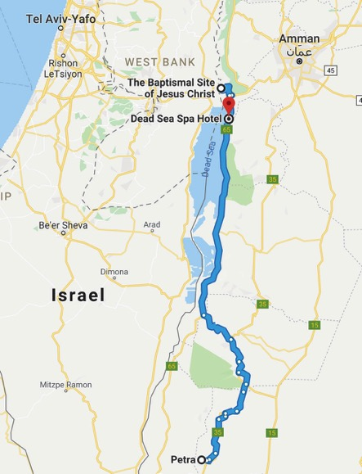

Day 4 – Bethany (Beyond the Jordan) & The Dead Sea Spa
oday as we leave Petra, we will be driving north along the Dead Sea Road and will make our way to Bethany Beyond the Jordan. Here, we will have an opportunity to be baptized in the place where many believe that John the Baptist lived and baptized Jesus. We will
T
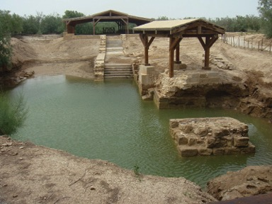
learn of Jesus’ baptism as it is discussed in John 1:19-34.
There are three other important biblical events which traditionally may have happened at this location or else nearby.
The first, is a very important event in the history of Israel – Joshua leading Israel as they crossed the Jordan river into the promised land (on dry ground). In Joshua 3:14-17, this amazing story is the bookend of the exodus from Egypt. In that event, God delivered Israel from the Egyptians, allowing them to leave Egypt once and for all, by crossing the parted Red Sea on dry ground. But in Joshua 3, having wandered in the wilderness for 40 years, Israel is about to enter the land of Canaan, by crossing the Jordan river on dry ground. This is the be- ginning of the fulfillment of God’s promise made to Abraham back in Genesis 15:13-21. Many lessons even for us today can be learned as we think back to God’s faithfulness to His people in this place over 3,000 years ago.
The second, another event took place several hundred years later,

which involved the crossing of the Jordan river on dry ground. In 2 Kings 2:1-14 we read the story of Elijah as he was taken up to heav- en in a whirlwind. It is from this place, the Jordan river across from Jericho, where Elijah passed his ministry on to his disciple, Elisha.
Lastly, our Lord Jesus made this a place of escape from those who were trying to stone Him in Jerusalem. We read about this in John 10:22-42. In the place where John had prepared the way for Jesus’ ministry, Jesus returned and many believed in Him there. This is the place where we, who also believe, can be thankful for the Lord’s willingness to come and seek and save those who were lost – including us!
Finally, we will drive to the place we will stay for the evening, the Crown Plaza Dead Sea. Here we can enjoy the remains of the day to perhaps soak in the mineral rich Dead Sea (floaties not needed), or to take in a spa treatment. We will enjoy a nice dinner and spend the night.

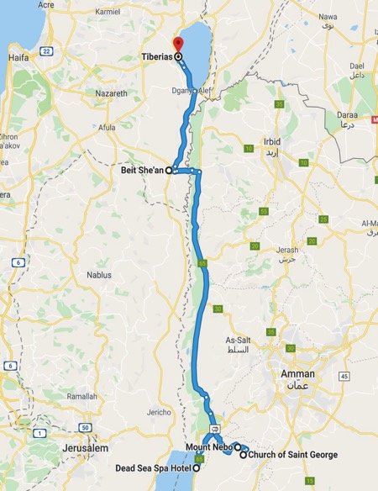

Day 5 - Mt. Nebo, Border Crossing, Galilee

Madaba and its Map
M
ore than a million pieces of colored stone and glass lie on the floor of a church in the Jordanian city of Madaba. This unique
art treasure was designed in the middle of the 6th century, located in the Greek Orthodox Church of St George which has been built over it. The original map is 15.5 by 5.5 meters covering an area from Lebanon in the north to the Nile delta in the south. It is one of the most accu- rate maps of the Holy Land from ancient times. Uniquely, the map is oriented towards the east with the Jordan river flowing across the map from left to right.
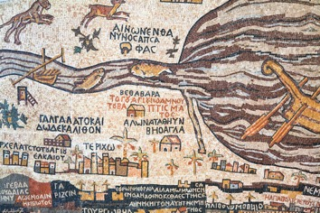

About 150 inscriptions in Greek name various biblical events and locations using colored stones and glass, such as Jericho, Jacob’s Well, the Oak of Mamre at Hebron, John’s baptism of Jesus, and the allot- ments of the 12 tribes of Israel. The map’s dominant focus is on the city of Jerusalem, presenting its walls, gates, main streets and specific buildings, including the Church of the Holy Sepulcher.
The purpose of the map is not known but several suggestions are given:
- As an aid for pilgrims making their way to the holy places.

  - As a representation of Moses’ vision of the Promised Land as he viewed the Promised Land from the top of nearby Mount Nebo.
  - To provide a spiritual experience for worshipers during their ser- vices as it was situated on the floor of a church.
More emphasis is placed on the Church of the Holy Sepulcher than on Old Testament locations, focusing more on the message of salvation.
Madaba the town was an important town in the early centuries of the Christian era. But it was destroyed by an earthquake in 746 AD and it lay abandoned until the early 1880s. Now Madaba is the 5th largest city in Jordan. (ref: seetheholyland.net)

Mt. Nebo
Mount Nebo, located in western Jordan is 820 meters high, look- ing down 1220 meters over the nearby Dead Sea. Over 3,500 years ago Moses stood on the summit of Mount Nebo, while viewing the
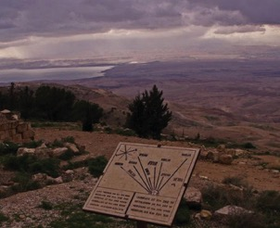
Promised Land. But like most of the Israelites that came out of Egypt Moses also died without being allowed to enter the land promised to Abraham. Deuteronomy 34:5-6 tells of Moses’ death and burial. Moses led the people of Israel for 40 years. Interestingly though, Moses did eventually enter the Promised Land (see Luke 9:28-36).
From this view, on a clear day, people can see the same panorama Moses viewed. This includes the Dead Sea, the Jordan River valley, Jericho, Bethlehem and the distant hills of Jerusalem. (ref: seetheholy- land.net)

Jordan – Allenby Bridge Crossing:
This famous bridge is also known as the King Hussein Bridge. In 1918 General Edmund Allenby built his bridge over the remnants of an Ottoman era bridge. It was destroyed in 1946, and again during the Six Day War in 1968 and replaced with a temporary structure. In the 1990s the Israel-Jordan peace treaty allowed for the new modern bridge to be built that is still in use today.

Beth She’an
Beth She’an is one of the most incredible archaeological sites in Israel. It has some of the best-preserved ruins in the Middle East. It was also the location of one of the most ghoulish events in the Bible. King David, who succeeded Saul as king, wrote a lament over the tragedy, with the recurring line “How the mighty have fallen” in 2 Sam 1:17
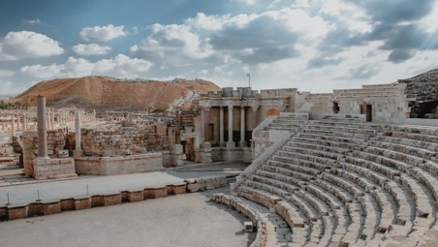
– 27.
Beth She’an is about 13 km south of the Sea of Galilee. During the Roman period it was the leading city of the Decapolis. Excavations have revealed a thriving city with a 7,000 seat theater; 6,000 seat amphitheater for gladiator performances; a huge bath and gym com- plex with swimming pool; public toilets with running water; a Roman basilica and administrative center; and a nymphaeum. Christians and Muslims lived together until the disastrous earthquake in 749 AD. (ref: seetheholyland.net)

Sea of Galilee
The Sea of Galilee has changed relatively little since Jesus walked on its shores and called four fishermen as his disciples. This picturesque lake is set among the hills in northern Israel. It has also been called the Sea of Tiberias and the Lake of Gennesaret (in Hebrew). It is both fed by the Jordan River and drained by it, serving as Israel’s main water reservoir.
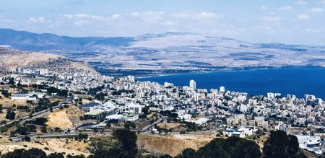
In Jesus’ time its main industry was fishing. Jesus’ ministry in Galilee was often located in the fishing town of Capernaum. Much of the life of Jesus in the Gospels tells of His time in and around this beautiful lake. And it is the place where He came back and met Peter after the resurrection.
Sudden storms, as seen in the Gospels, are common on the Sea of Galilee because it lies low in the valley, surrounded by hills. In 1986, the remains of an ancient fishing boat were found in the lake bed. It was old enough to have been on the water in the time of Jesus and his disciples. Dubbed the Jesus Boat, it is now on permanent display at the lakeside Kibbutz Ginosar.
This place, Kibbutz Ginosar, is where we will spend the next three nights. A kibbutz (in Hebrew: “gathering, clustering”) is a collective community in Israel that was traditionally based on agriculture. Today, farming has been partly supplanted by other economic branches, including industrial plants and high-tech enterprises. Kibbutzim began as utopian commu- nities, a combination of socialism and Zionism. In recent decades, many kibbutzim have been privatized and changes have been made in the com- munal lifestyle. A member of a kibbutz is called a kibbutznik.

Related Biblical References:
Numbers 20:8-12; Deut. 32:48-52; 1 Cor. 10:4; Exodus 17:6; Heb. 7:27
– Moses’ sin and tragic consequences.
Deut. 34:1-12 – Moses last days, on Mt. Nebo Luke 9:28-36 – Moses meets with Jesus Judges 1:27 – Canaanites of Beth Sh’ean
1 Sam. 31:1-13; 2 Sam. 1:17-27 – The death of Saul; Lament of David Luke 5:1-11 – Fishing for men

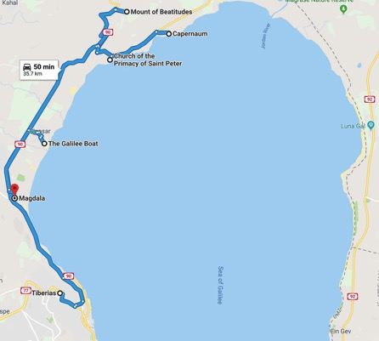

Day 6 - Northern Galilee

Church of the Beatitudes
T
his octagonal church was built to commemorate the eight Beatitudes in Jesus’ Sermon on the Mount. This is the tradition-
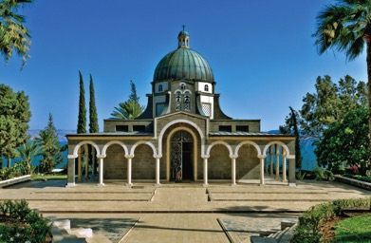
al location where Jesus taught this sermon overlooking the Sea of Galilee.
The suggestion of this hill for the location of the sermon is a good one. Once known as Mt. Eremos, this hill is located between Capernaum and Tabgha and is just above the “Cove of the Sower.” This spacious hillside provides much room for crowds to gather, as evidenced by preparation for 100,000 Catholics who observed mass nearby with the Pope in March 2000.
Inside the church the sisters encourage you to sing, to enjoy the beau- tiful acoustics and worship God.

Church of the Primacy of St. Peter
Tabgha is an area situated on the north-western shore of the Sea of Galilee in Israel. It is the traditional site of the miracle of the multipli- cation of the loaves and fishes (Mark 6:30-46) and the fourth resur- rection appearance of Jesus where He restores Peter in John 21. This would be the shoreline where the miraculous catch took place after Jesus’ resurrection, followed by breakfast around a campfire.

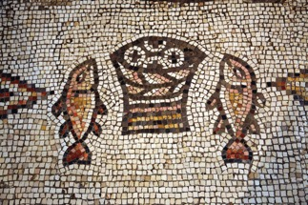
This is in the same vicinity where tradition says Jesus baptized His disciples. Until 1948, it was the site of an Arab village.

Capernaum
Capernaum (“Nahum’s village”) was a fishing village inhabited from mid 2nd century B.C. to 11th century AD. It is located on the north- western shore of the Sea of Galilee and had a population of about 1,500. Recent excavations revealed that there were two synagogues in the village: the more recent was made of limestone and was built on top of the older, which was made of local black basalt. Only the foun- dation walls, some columns, and the cobblestone floor remain of the earlier structure. This older structure was most likely the one in which Jesus had taught.
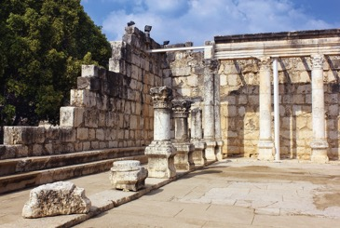

A church near Capernaum is said to be the home of Peter. When Jesus left Nazareth he settled in Capernaum where he chose his first four disciples; James, John, Peter and Andrew.
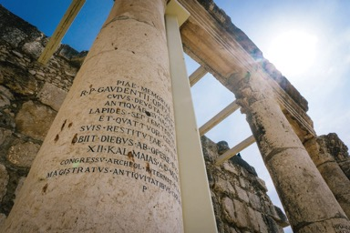
The town is cited in the Gospel of Luke where it was reported to have been the home of these disciples, as well as the tax collector Matthew. In Matthew 4:13 the town was reported to have been the home of Jesus. According to Luke 4:31-44, Jesus taught in the synagogue in Capernaum on the Sabbath. Jesus then healed a man who had the spirit of an unclean devil and healed a fever in Simon Peter’s mother- in-law. According to Luke 7:1-10, it is also the place where a Roman Centurion asked Jesus to heal his servant.
Josephus referred to Capernaum as a fertile spring. He stayed the night there after spraining his ankle. During the first Jewish revolt of 66-70 Capernaum was spared as it was never occupied by the Romans.

Khorazim
Chorazin (or Khorazim) is one of the three Galilean cities cursed by Jesus; the other two being Bethsaida and Capernaum. Most of Jesus’ teachings and miracles occurred there. According to Matthew 11:10- 24, their people did not accept his teachings and repent in spite of the miracles Jesus performed there.
The remains of an elaborate synagogue built in the 3rd or 4th century are a striking feature of the ruins of Chorazin. Found in the ruins of the syna- gogue was the Seat of Moses, from which the Torah would have been read.

Jesus Boat
In 1986 the hull of a fishing boat old enough to have been on the water in the time of Jesus and his disciples was discovered. The remains
were 27 feet long, 7.5 feet wide and 4.3 feet high. This size would have enabled it to carry up to 15 people.
Although there is no evidence that this boat was used by Jesus or his disciples, boats such as this are mentioned more than 50 times in the Gospel accounts of Jesus’ ministry in Galilee. It is interesting
that the boat is dated to have been used between 120 B.C. and 40 AD. Certainly Jesus had been in fishing boats like this one, if not this one.

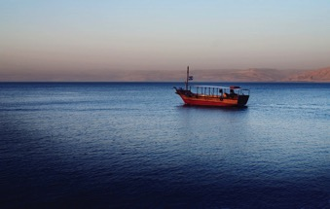
Boat ride across Galilee
We will be taking a sunset boat ride across the Sea of Galilee. This experience will allow each person to contemplate that 2,000 years ago Jesus also spent time with his disciples in a boat on this same lake, with relatively the same views.

Magdala
Magdala is located on the northern end of the Sea of Galilee. It was a prosperous fishing village during Jesus’ day. As a major port and a cen- ter of trade and commerce, it even exported salted fish to markets as far away as Europe. Magdala is also one of the newest archaeological sites in the region. Several important artifacts have been found there dating from the time of Jesus, and also a large Byzantine monastery.
Its fame rested on one notable person, Mary Magdalene. This woman was one of the few persons present at Christ’s crucifixion and also the first recorded witness of his Resurrection.

Whether she lived in Magdala or was simply born there is unknown, but she was apparently a wealthy woman. Mary was a close follower of Jesus. Luke says she had been cured of “seven demons” and also had accompanied Jesus, supporting his ministry from her own resources (Luke 8:2-3).
She was also one of the women who took spices for anointing to the tomb, when they found the tomb empty! Two men in dazzling
clothes gave them the news that Jesus had risen. (Luke 24:1-12) Jesus appeared to Mary, but she confused him with the gardener. But she finally recognized him when he spoke her name. Then she announced to the disciples, “I have seen the Lord” (John 20:1-18).
This city that gave its name to Mary Magdalene was turned into a for- tified base for rebels during the First Jewish Revolt in AD 66-70.
In 1986 the hull of the so-called Jesus Boat, was found in the lake bed near the ancient port of Magdala.

Related Biblical References:
Matt 5:3-11 – “Blessed” statements from Jesus (also see Matt 5-7) Luke 6:20-49 – Luke’s version of the Sermon on the Mount
Mark 6:30-46 – Miraculous feeding John 21:1-25 – Jesus’ restoration of Peter
Luke 4:21-44; Matt 8:5-13; 9:1; 9:9-12; 11:20-22 – Many stories of Jesus in Capernaum
Matthew 11:20-24; Luke 10:13-14 – Jesus condemns Chorazin Mark 4:35-41 – Jesus stills the storm
Matthew 13:1-9 – Jesus tells parables from a boat Luke 5:1-11 – The miraculous catch of fish Matthew 15:39 – Jesus visits Magdala by boat Luke 8:2 – Mary cured of seven demons
Luke 8:3 – Mary supports Jesus’ ministry
Matthew 28:1-10; Mark 16:1-8; Luke 24:1-12; John 20:1-18 – Mary goes to Jesus’ tomb
John 20:18 – Mary announces the Resurrection to the disciples

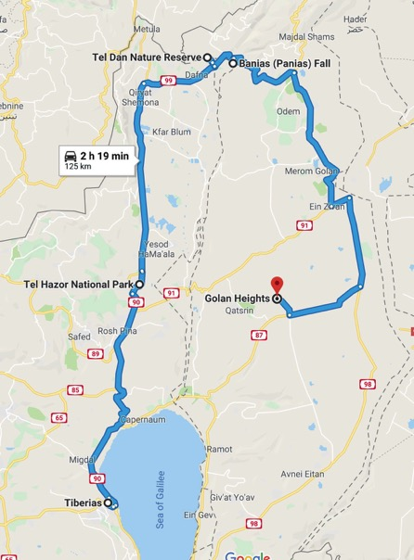

Day 7 - Hazor, Tel Dan, Golan Heights

Hazor
T
he tell of Hazor is today the largest archaeological site in Israel at 200 acres. It was an ancient Canaanite and Israelite city located
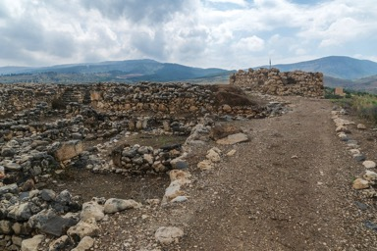
in the upper Galilee region of Israel, assigned to the tribe of Naphtali (Josh 19:36).

Located along the route from Damascus to Megiddo, Hazor had stra- tegic importance. The earliest reference to Hazor dates to the late 19th or 18th century B.C.. It may have supported a population of 40,000 during the Bronze Age.
The Bible first introduces Hazor in the context of Israel’s conquest of Canaan. Joshua 11:10 refers to Hazor as “The head of all those king- doms”. The Israelites defeated the Canaanites, killed Jabin, and burned the city to the ground.
But during the time of the judges, the Canaanites are back in control of Hazor under the leadership of Jabin king of Canaan. Judges 4 re- cords the story of Deborah and Barak who defeat this army with nine hundred iron chariots.
Hazor became an important Israelite city during Solomon’s reign, as

Solomon built up garrison cities and strategic bases. Hazor, Megiddo, and Gezer were the most important of these cities (1 Kgs 9:15). The last historical reference to Hazor indicates that the city fell to Assyria in 732 B.C., along with other cities in the northern kingdom of Israel (2 Kgs 15:29).
Archaeologists have uncovered a six-chambered gate at Hazor, which is nearly identical in size and design to gates at Megiddo and Gezer. These gates are a remarkable testimony to Solomon’s building activity as described in 1 Kings 9:15.

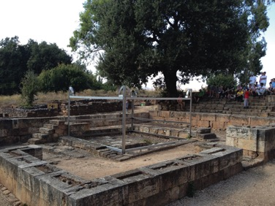
Tel Dan
The last chapters of Judges show Samson of the tribe of Dan fighting the Philistines. Eventually Dan migrated to the north and was able to take a city called Laish. They renamed the city Dan and settled in the area around it. Dan was always a small tribe, and it never exercised significant influence in Israel.
The biblical city of Dan is often mentioned in the description of the land of Israel, namely “from Dan even to Beersheba” (Judg. 20:1). The tell, which covers about 50 acres, is situated at the northern end of the richly fertile Huleh Plain at the base of Mount Hermon. The abundant springs of the site provide one of the three main sources of the Jordan River. The city was formerly named Laish (Judg. 18:7, or Leshem in Josh. 19:47) when occupied by the Canaanites.

Following the establishment of the Israelite kingdom under David and Solomon, Jeroboam led the Northern tribes in revolt against Rehoboam (about 925 B.C.). As an alternative to worship in Jerusalem, Dan and Bethel were fortified as border fortress/sanctuar-
ies (1 Kings 12:29) with temples containing golden calf representations of Yahweh. This may have represented a combination of Baal worship with worship of Yahweh. The extent to which the Baal cult influenced Northern Israel is seen in the reign of Jehu, who did not destroy the altars at Dan and Bethel, despite eradicating the Baal priests from the land (2 Kings 10:23–29).
Excavations at Dan have uncovered the “high place” of Jeroboam along with a small horned altar, the city gate (with royal throne) and walls (12 feet thick), hundreds of pottery vessels, buildings, and in- scribed objects.
This city was soon taken by Ben-hadad of Aram and then recaptured by Jeroboam II in the eighth century B.C. (2 Kings 14:25). The Israelite city of Dan fell to the Assyrians under Tiglath-pileser III (Pul of OT) about 743 B.C. (2 Kings 15:29). He annexed the city into an Assyrian district. Many Danites were deported to Assyria, Babylon, and Media following the fall of Samaria in 722 or 721 B.C. (2 Kings 17:6) to Sargon II. Foreigners were brought in from Babylon, Aram, and other lands to settle Israel’s territory.
The writer of Kings ascribed the fall of the kingdom to the worship of gods other than Yahweh (2 Kings 17:7–20), and Dan was one of the key centers of this idolatry. As Josiah came to the throne of Judah in 639 B.C., Assyria was on the decline. Josiah incorporated the former Northern Kingdom territories into a united country, restoring the classical borders of Israel to “from Dan to Beersheba.” An upper gate to the city was built during this period, and the inscription found at this level, “belonging to Ba’alpelet,” demonstrates that Baal worship continued to influence this area after the Assyrian destruction. The partially rebuilt city survived until the onslaught of the Babylonian army of Nebuchadnezzar (about 589 B.C.; cp. Jer. 4:14–18).
(by R. Dennis Cole, Holman Illustrated Bible Dictionary)

Caesarea Philippi
Situated 25 miles north of the Sea of Galilee and at the base of Mt. Hermon, Caesarea Philippi is also the location of one of the larg-

est springs feeding the Jordan River. This abundant water supply has made the area very fertile and attractive for religious worship.
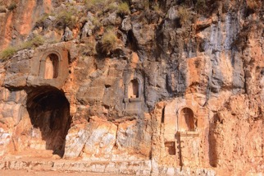
Numerous temples were built at this city in the Hellenistic and Roman periods. Apparently known as Baal Hermon and Baal Gad in the Old Testament period, this site later was named Panias after the Greek god Pan who was worshiped here. There is no record of Jesus entering the city, but the great confession and the transfiguration both occurred in the vicinity of the city, then known as Caesarea Philippi. Matt. 16:13; Mark 8:27
During the Jewish-Roman War of A.D. 66–70, the Roman general Vespasian rested his army here. After the war, Titus, who succeeded his father as general of the Roman armies, held gladiatorial shows here during which a number of Jewish prisoners were put to death. After subduing the Jews, the Romans changed its name back to Paneas. (W.T. Edwards Jr. – Holman Illustrated Bible Dictionary)

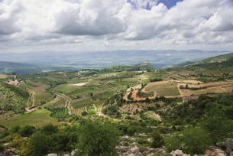
Golan Heights

An area of highlands, mountains, and volcanic ash cones northeast of the Sea of Galilee; composed of the regions previously called Bashan, Karnaim, and Gaulanitis. A refuge city called Golan was located in Bashan (Deut 4:43; Josh 20:8; 21:27; 1 Chr 6:71).
The region has been called the Golan Heights only since the 19th cen- tury. The Golan Heights has been inhabited and fought over for mil- lennia. The area provides 15 percent of modern Israel’s water supply. Israel regained control of the Golan Heights from Syria during the Six Day War of 1967. (R.L. Drouhard – Lexham Bible Dictionary)

Bethsaida
Bethsaida was a fishing village located on the northern shore of the Sea of Galilee. The Gospels mention the town of Bethsaida by name seven times (Matt 11:21; Mark 6:45; 8:22; Luke 9:10; 10:13; John 1:44; 12:21). Three of Jesus’ disciples, fishermen by trade, were from Bethsaida. However, Matthew 8:5, 14 suggest that Peter (and possibly Andrew, as well) had moved to Capernaum at some point.
Jesus performed several miracles in Bethsaida, including:
- Feeding the 5,000 (Luke 9:10–17)
- Healing a blind man (Mark 8:22–26);
- Walking on water (Mark 6:45–51).
Jesus also condemned the town of Bethsaida (Matt 11:21; Luke 10:13). The Gospels portray the townspeople as fickle and narcissistic; al- though they saw Jesus’ miracles and received His blessings, most people did not believe in Him (Matt 11:14–24).
(R.L. Drouhard – Lexham Bible Dictionary)

Related Biblical References:
- Joshua 11:1-13 – Joshua defeats Canaanites in Hazor
- Judges 4:1-24 – Deborah and Barak defeat king of Hazor
- 1 Kings 9:15ff – Solomon rebuilds Hazor
- 2 Kings 15:29 – Assyria destroys Hazor
- Judges 18:1-31; 20:1 – Laish becomes Dan
- 1 Kings 12:25-33 – Jeroboam sets up golden calves
- 2 Kings 10:23-29; 17:6-23; Jer 4:14-18 – Partial cleansing of Baal

worship and God’s judgment for idolatry
  - Matt 16:13-28; Mark 8:27-9:13 – Jesus at Caesarea Philippi
• Matt 11:21; Mark 6:45; 8:22; Luke 9:10; 10:13; John 1:44; 12:21 –
Bethsaida in the Gospels

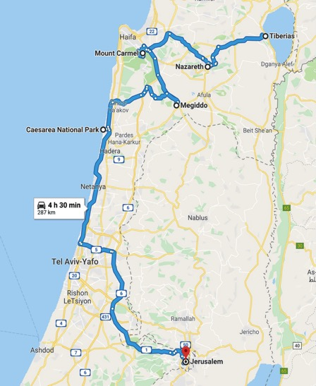

Day 8 - Nazareth, Megiddo, Caesarea, Jerusalem

Nazareth
A
Byzantine church was built over the place where it is believed that the angel Gabriel announced the birth of Jesus to the virgin Mary.
In 1966 the Roman Catholic Church began constructing a new basili- ca over these remains and today this church is the largest church building in the Middle East. The Greek Orthodox Church nearby is built over the town’s water source.
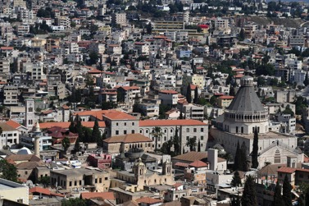
Jesus spent his boyhood years in Nazareth before beginning his min- istry when he was about 30. After moving his home to Capernaum, Jesus returned to teach in the synagogue of Nazareth twice more, but was rejected both times. On one occasion the townspeople were so outraged at Jesus that they tried to throw him off a cliff to his death.

Megiddo
Megiddo is a hill in modern Israel near the Kibbutz of Megiddo, known for its historical, geographical, and theological importance especially under its Greek name Armageddon.

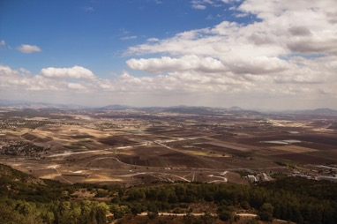

In ancient times Megiddo was an important city-state. It is also known alternatively as Tel Megiddo (Hebrew). Megiddo is a tel (hill or mound) made of 26 layers of the ruins of ancient cities in a strategic location at the head of a pass through the Carmel Ridge, which over-
looks the Valley of Jezreel from the west. The name Armageddon men- tioned in the New Testament derives from Har Megiddo (Hebrew) meaning Mount of Megiddo.
Megiddo was a site of great importance in the ancient world, as it guarded the western branch of a narrow pass and an ancient trade route which connected the lands of Egypt and Assyria. Because of its strategic location at the crossroads of several major routes, Megiddo and its environs have witnessed several major battles throughout his- tory. One of its claims to importance is the fact that since this time it has remained uninhabited, thereby preserving the ruins of its time pe- riods pre-dating 586 B.C. without newer settlements disturbing them.
At Megiddo two stable complexes were excavated, one in the north and one in the south. Both complexes could hold from 450-480 horses combined.
Josh. 12:21; Josh. 17:11; 1 Kings 19:5; Zech 12

Mt. Carmel
The Carmel range is approximately 6.5 to 8 km (4 to 5 miles) wide, sloping gradually towards the southwest, but forming a steep ridge on the northeastern face, 1,810 ft high. The Jezreel Valley lies to the

immediate northeast.
Mt. Carmel was most significant in ancient times as a barrier to traffic along the coastal plain. The 1500-foot high limestone mountain im- peded armies and merchants traveling to the Jezreel Valley. Biblically, Mt. Carmel is referenced most often as a symbol of beauty and fer- tility. To be given the “splendor of Carmel” was to be blessed indeed (Isa 35:2). Solomon praised his beloved: “your head crowns you like Mount Carmel” (Song 7:5). But for Carmel to wither was a sign of devastating judgment (Nahum 1:4). This is probably the best view of the area of Elijah’s contest, assuming tradition is correct. The monas- tery of Muhraqa is at the top of the hill, but tradition places the con- test slightly lower near a spring. The crowds of Israelites would have filled the spacious territory around to see whose God would win in the battle between Baal and Yahweh.

Caesarea Maritima
In the attractive Mediterranean seaport of Caesarea Maritima, the apostle Peter baptized the first recorded gentile convert to Christianity
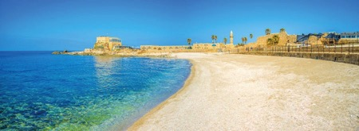
— Cornelius, a centurion in the Roman army. When this Italian soldier and his household believed in Jesus they received the gift of the Holy Spirit and began speaking in tongues. This event astonished the Jewish Christians but validated the fact that salvation was for all people (Acts 10).
Caesarea Harbor was the scene of other significant events for Christians:
- It was the headquarters of Pontius Pilate. From here the Roman procurator set out for the Passover festival in Jerusalem, where he sentenced Jesus to death.
- Here the apostle Paul was imprisoned for two years and preached

to the last of the Herods, King Agrippa II, who said that if he were to listen any longer to Paul’s persuasion he might become a Christian.
  - The city was the home of Philip the evangelist and his four daugh- ters, who were prophetesses. Paul stayed with them when he returned from his missionary journeys.
  - At Philip’s home, a prophet named Agabus bound Paul’s (or his own) hands and feet with his belt, foretelling how the apostle would be handed over to the Romans.
After Jerusalem was destroyed, Caesarea became the center of Christianity in Palestine. A Church council held here in AD 195 deter- mined that Easter should be celebrated on a Sunday.
Not to be confused with Caesarea Philippi in Galilee – was found- ed by Herod the Great on the site of an ancient fortified town. In 22 B.C., with no expense spared, he began building a new city and har- bor. Massive breakwaters gave safe anchorage to 300 ships, a sewage system was flushed by the tide, and a vast hippodrome seated more
than 20,000 people at chariot races. Later an amphitheater was built to present chariot races, gladiatorial combats, animal performances and theatrical events. Little wonder that Caesarea has been dubbed “Vegas on the Med.”
During the Roman occupation, clashes between Jews and the majority Greco-Syrian population, who supported Rome, were frequent. The desecration of Caesarea’s synagogue and the massacre of 20,000 Jews
— in a single hour, according to the historian Josephus — culminated in the First Jewish Revolt, which ended with the AD 70 destruction of both Jerusalem and the Second Temple.
Well-known Christian Fathers who were active in Caesarea included Origen and Pamphilius. The library they built up was second only to that of Alexandria (in the 7th century it held 30,000 works). Eusebius, who became bishop in 314, was both the first Church historian and the first biblical geographer. Without his book of place names, the Onomasticon, many biblical sites would never have been identified.
Today’s visitors can see a restored Roman theatre built to accommo- date 4000 and a Roman aqueduct that brought water from the foothills of Mount Carmel. Just inside the theatre is a replica of an inscription carved in stone, bearing the name of Pontius Pilate. The remains of a

Crusader walled city, from the 13th century, include a cathedral which was never completed because the vaults below, from an earlier period, were unable to bear the weight. (from Seetheholyland.net)

Jerusalem
The city dates back to the 4th millennium B.C., making it one of the oldest cities in the world. During its magnificent history, Jerusalem has been destroyed twice, besieged countless times, attacked at least 52 times, and captured and re-captured over 40 times right down to our own time. The city of Jerusalem may be the “Salem” of Melchizedek (Gen 14) but is first called by its common name in Joshua 10. Later known as Jebus (Judges 19:10) this Jebusite city was conquered by David (2 Samuel 5:6ff) and it became his capital. Jerusalem is a holy city to Jews, Christians, and Muslims. Many of its sites are operated by all three in an unusual show of harmony.
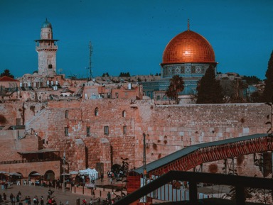
The Old City (Jerusalem): This is the term used to designate the his- torical “core” of the modern city of Jerusalem. It is a 1/3 square mile walled area, divided into the Jewish Quarter, the Christian Quarter, the Armenian Quarter, and the Arab/Muslim Quarter. The Old City is home to many important sites including Temple Mount, the Western Wall, the Church of the Holy Sepulcher, the Dome of the Rock, and many more.
We will be staying this city for seven days and six nights. It is sure to

be one of the most memorable experiences of your life.

Related Biblical References:
  - Luke 1:26-38 - Gabriel’s announcement to Mary
  - Matt 2:19-23; 4:12-13; Luke 2:39-40,51-52 – Jesus grows up in Nazareth
  - Luke 4:14-30; Mark 6:1-6 - Jesus rejected by His home town
  - 2 Kings 9:14-27; 23:28-30; 2 Chron 35:20-24 - Death of kings in Megiddo
  - Rev 16:13-16; 19:11-21 - The battle of Armageddon
  - 1 Kings 18:1-46 - Prophets of Baal vs. Elijah the Prophet of Yahweh
  - Acts 8:39-40 - Phillip arrives in Caesarea
  - Acts 10:1-48 - Gentiles receive the Holy Spirit
  - Acts 12:1-25 - Herod Agrippa dies in Caesarea
  - Acts 23:23—26:32 - Paul imprisoned in Caesarea

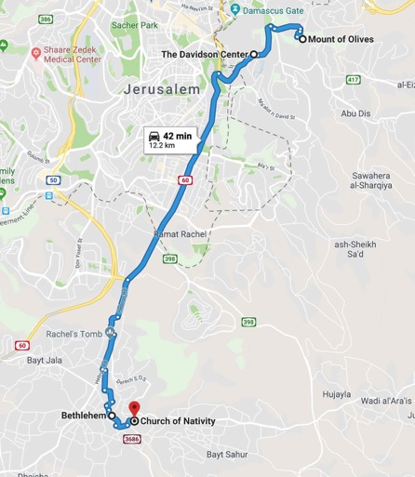

Day 9 - Jerusalem (1st full day)

Mount of Olives
M
ount of Olives: Also known as Mt. Olivet, this mountain range actually has 3 peaks running on the eastern side of Jerusalem. It
is named for the many olive groves that line its slopes. On the slope running down to the eastern wall of the city is a Jewish cemetery that has been in use for over 3000 years, and contains 150,000 graves.
Included are graves traditionally assigned to Zechariah, Absalom, Haggai, and Malachi. Jewish tradition holds that those buried closest to Messiah when he appears will rise first.
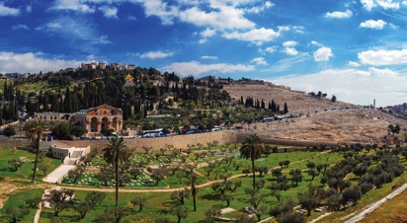
From the Mt. of Olives we can see Temple Mount, and the walls of the City of David. If there is time, we’ll leave the bus on top, and walk down the mountain road all the way to the Garden of Gethsemane.
As we walk we’ll pass hundreds of graves, decorated with stones and above ground. We’ll pass Dominus Flevit (see below) and the Church and Garden of Gethsemane. The Mt. of Olives is very important to the biblical course of history: 2 Samuel 15:30; 1 Kings 11:7,8; Ezekiel 11:23; In Zechariah 14:4 a prophecy states that Messiah will one day stand on the Mount and it will be split in half.
Dominus Flevit: This is a small Fransciscan church located on the upper western slope of the Mount of Olives in Jerusalem. Dominus Flevit, which means “the cry of the Lord,” commemorates the time when Jesus stood and wept over Jerusalem (Luke 19:41). The current

Dominus Flevit Church was commissioned by the Franciscans, who still run the site, and designed by Italian architect Anton Barluzzin. Constructed in 1954, the church is in the shape of a tear drop to symbolize the Lord’s tears. The current church stands on the ruins of a 7th-century church, some mosaics of which still remain. The western window in Dominus Flevit provides a beautiful view of the Temple Mount.
During the construction of the modern church, an ancient Jewish tomb dating to as early as the first century B.C. was discovered be- neath. The tomb and several ossuaries (bone boxes) can be seen by visitors.

Southern Temple Mount and Steps
Excavations begun by Benjamin Mazar in 1968 were the largest
earth-moving archaeological projects in Israel. Work continued until 1978 but has since resumed in the 1990s under the direction of Ronny Reich. These excavations are the most important for understanding the Temple Mount because of the impossibility of excavating on the mount itself.
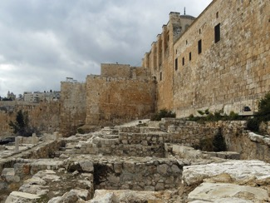
A street in this area was fully uncovered in the mid-1990s and dates to the decades before the city’s destruction by the Romans in AD 70. The street is 32 feet (10 m) wide and was paved with large slabs up to a foot thick. It was covered with massive stones pushed down by the Romans; only part of the street has been cleared by the excavators.
The western flight of stairs leading to the main entrances of the

Temple Mount was 200 feet wide. Excavators uncovered the eastern- most part of this staircase with its alternating long and short steps.
Some suggest that the fifteen long steps may have been one of the locations where pilgrims sang the fifteen Psalms of Ascent (120-34) as they went up to worship. (from BiblePlaces.com)

Bethlehem
The West Bank city of Bethlehem, about 9km south of Jerusalem, is celebrated by Christians as the birthplace of Jesus Christ.
Here Mary gave birth in a cave used for animals. Here the local shep- herds came to worship the baby, and here the Wise Men from the east came to pay homage and present their gifts. Here too, 1000 years before Christ, Bethlehem was the birthplace of David, Israel’s second king. Here David was anointed as king by the prophet Samuel after being brought in from tending his father’s sheep.
The city of Bethlehem (in Hebrew its name means “house of bread”) perches on a hill at the edge of the Judean desert. The cave where the birth took place and the manger stood can now be visited underneath the huge Basilica of the Nativity. This is the oldest complete church in the Christian world.
During the 20th century, Bethlehem was controlled in turn by Turkey, Britain, Jordan and Israel. Hostilities led to thousands of displaced Palestinians living in official refugee camps nearby. In 1995 Bethlehem came under the administration of the Palestinian Authority, though Israel retained control of entrances and exits. During times of Israeli- Palestinian conflict, the city has seen many confrontations.
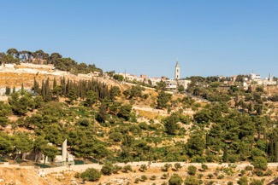

Maintaining the Christmas spirit, Franciscan friars daily celebrate the Eucharist in the Grotto of the Manger and at noon perform a proces- sion around the holy places. Bethlehem’s residents, who depend large- ly on pilgrims and tourists for their livelihood, are known for their olive wood carvings, mother-of-pearl jewelery (a craft introduced by the Franciscans) and distinctive embroidery.
In the words of one pilgrim, Della Shenton, “Bethlehemites are cheer- ful, peaceful, gentle people, who have welcomed pilgrims for centu- ries: They now stand waiting for visitors.”

Various historical sites in the Bethlehem area:
Church of the Nativity - the oldest complete church in the Christian world, was built by the emperor Justinian in the 6th century. It re- placed the original church of Constantine the Great, built over the cave venerated as Christ’s birthplace, and dedicated in AD 339.
Grotto of the Nativity - the place of Christ’s birth is a dimly-lit rock cave. Instead of a star above, a 14-point silver star on the marble floor of the Grotto of the Nativity bears the words “Hic de Virgine Maria Jesus Christus natus est” (Here Jesus Christ was born to the Virgin Mary)
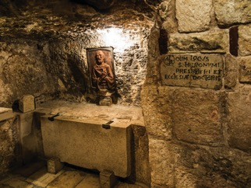
St. Jeromes Cave - From a cave beneath the Church of the Nativity in Bethlehem came the most enduring version of the Bible ever translat- ed. In this underground study — pleasantly cool in summer but chilly in winter — St Jerome spent 30 years translating the Scriptures from Hebrew and Greek into Latin.

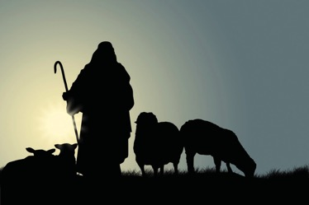
Shepherd’s Field - Caves where shepherds “kept watch over their flock” still abound in the area east of Bethlehem. Here, the Gospel of Luke tells us, an angel announced the birth of Jesus. The traditional place of the angel’s visit is the town of Beit Sahur. Originally known as the Village of the Shepherds, it is now an eastern suburb of Bethlehem.
Tomb of Rachel - The death of Rachel, beloved wife of the patriarch Jacob, is remembered on the Jerusalem-Hebron road north of Bethlehem. The tomb, a small building with a white dome, is now hidden behind a long bunker-like structure with guard towers and barbed wire.
Field of Boaz - The romantic story of the Moabite woman Ruth, who is remembered for one of the most celebrated statements of devotion in the Old Testament, is linked to a field near Bethlehem. The Field of Boaz is east of the Palestinian town of Beit Sahour, in the fertile plain that descends to the Dead Sea.

Related Biblical References:
- 2 Sam 15:25-30 - David flees from Absalom
- 1 Kings 11:6-10 - Solomon builds high places for the gods of his wives
- Ezekiel 11:23 - God’s glory leaves Jerusalem
- Zech 14:1-4 - 2nd Coming of the Messiah
- Psalms 120-134 - Psalms of Ascent
- Micah 5:2-5 - Birth of Messiah prophesied

  - Luke 2:1-20; Matt 1:18-25 - The birth of Jesus
  - Matt 2:1-12 - The visit of the Wise Men
  - Matt 2:16-18 - Massacre of the Holy Innocents

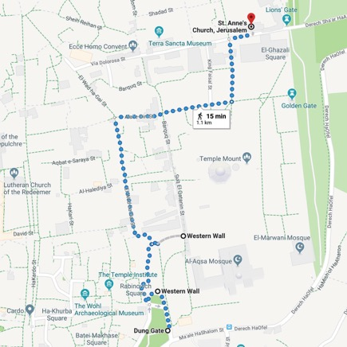
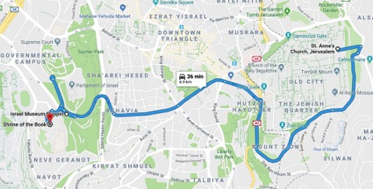

Day 10 - Jerusalem (2nd day)

Western Wall
J
udaism’s holiest place is the Western Wall in the Old City of Jerusalem. Part of the retaining wall erected by Herod the Great in
20 B.C. to support the vast plaza on which he rebuilt the Temple, it is venerated as the sole remnant of the Temple.
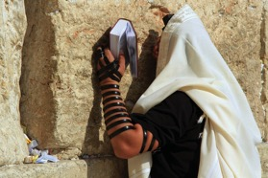
The wall and the plaza in front of it form a permanent place of wor- ship, a site of pilgrimage
for Jews and a focus of prayer — often petitions written down and placed between the huge stones. The Jewish name for the wall is the Kotel.
Orthodox Jewish men, ful- ly bearded and garbed in black, bowing their heads as they read and pray from
the Torah, are a common sight. It is also the place where Jews down the ages have expressed their grief over the destruction of the Temple, their anguish giving the wall another name — the Wailing Wall.
In the exposed part of the Western Wall today, the seven lowest layers of stones are from Herod’s construction. Most of these stones weigh between two and eight tons. Above these are stones placed in later centuries, replacing those forced out when the Romans put down a Jewish revolt by sacking Jerusalem and destroying the Temple in AD 70.
To the right of the plaza, near the southern end of the Temple Mount, large stones jutting out of the wall are the remains of what is called Robinson’s Arch. This arch once supported a grand staircase to the Temple. In the time of Christ a deep valley, spanned by bridges, ran beside the Western Wall and eight more levels of stones were visible. Through the centuries this valley, the Tyropoeon, has been progres- sively filled in with masonry and rubble.

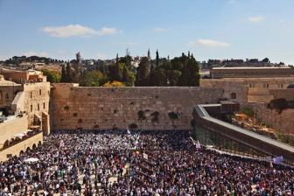
Mark 13:1 recounts that one of Jesus’ disciples exclaimed to him as they left the Temple: “Look, Teacher, what large stones and what large buildings!” Jesus replied: “Not one stone will be left here upon anoth- er; all will be thrown down.”
The Western Wall was captured by Jordan during the 1948 Arab- Israeli War and recaptured by Israel during the 1967 Six-Day War. Arab housing and mosques near the wall were immediately
razed. In their place, today’s plaza was created, stretching from the wall to the Jewish Quarter.
At the left end of the Western Wall is the entrance to a tunnel which allows visitors to walk along 500 meters of the extended wall, under buildings of the Old City. Sights include the biggest stone in the wall, estimated to weigh 570 tons. (from seetheholyland.net)

Rabbinical Tunnel
The tour of the western wall tunnels is one of the most popular tourist sites in Jerusalem. These underground tunnels
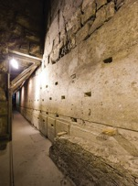
connect the western wall prayer area to the north-west side of the temple mount, passing along the side of the temple mount and under the present day houses in the Old City. Along its path are remains from the second temple period, as well as structures from later periods.
The experience of walking along the tunnels is like taking a time machine back to the time of the second temple. (from bible walks.com)

St. Stephen’s Gate
This gate is so named because of the tradition that the first Christian martyr was stoned outside this
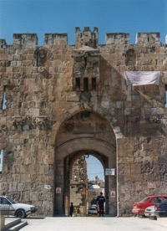
gate. Lions’ Gate is another name for this eastern entrance into the Old City because of the four animals that deco- rate the gate’s facade and reportedly placed there because of a dream of the builder Suleiman.

St. Anne’s Church
The Church of St Anne is the best-pre- served Crusader church in Jerusalem. It marks the traditional site of the home of Jesus’ maternal grandparents, Anne and Joachim, and the birthplace of the Virgin Mary. The New Testament says nothing about the birthplace of Mary.
However, an ancient tradition, recorded in the apocryphal Gospel of James which dates from around AD 150, places the house of her
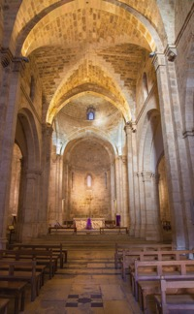
parents, Anne and Joachim, close to the Temple area. The Church of St Anne is renowned for its remarkable acoustics and reverberating echoes.
The voices of even a small choral group can sound like a large con- gregation in a vast cathedral. Unlike other churches in Jerusalem, St Anne’s was not destroyed after the Muslim conquest in 1189. Instead, it was turned into an Islamic law school by the sultan Saladin, whose name appears in the Arabic inscrip- tion still above the main entrance. (from seetheholyland.net)

Pools of Bethesda
Archaeology has enabled a pool at Bethesda in Jerusalem to be iden- tified as the scene of one of Jesus’ miracles. This was the healing of the paralyzed man who had waited for 38 years for someone to help him into the pool “when the water is stirred” — an event believed to have curative powers. The Gospel account says Jesus told the man, “Stand up, take your mat and walk”, and immediately he was made well (John 5:2-18).
The location of the Pools of Bethesda — actually a series of reser- voirs and medicinal pools — is in the Muslim Quarter of Jerusalem’s Old City, north of the Temple Mount and about 50 meters inside St Stephen’s or Lions’ Gate. At that time, the gate was called the Sheep Gate, because this was where sheep were brought to the Temple for sacrifice.
(from seetheholyland.net)

Model of Jerusalem
This is an outdoor scale model of the ancient city at the Israel Museum. The time is set in AD 66, the fateful year the Great Revolt against the Romans erupted, resulting in the destruction of the city and the Temple built by Herod the Great. All that’s missing from buildings of Jerusalem limestone are the people.
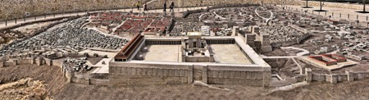
The crucifixion of Jesus Christ was only 36 years before, and the mound of Calvary can be seen just outside the Second Wall. The an- cient city was then at its largest, more than twice the size of the present Old City.
Construction of the Model of Ancient Jerusalem was undertaken in the 1960s by Hans Kroch, owner of the Holyland Hotel, in memory of his son Jacob, who was killed in the 1948 Arab-Israeli War. The model covers nearly 4000 square meters, using a scale of 1:50. (from seethe- holyland.net)

Shrine of the Book
The Shrine of the Book is a wing of the Israel Museum in western Jerusalem. It holds all seven of the scrolls found in what is called Cave 1 at Qumran, near the Dead Sea. They are Isaiah A, Isaiah B, the Habakkuk Commentary, the Thanksgiving Scroll, the Community Rule (or the Manual of Discipline), the War of the Sons of Light against the Sons of Darkness (or the War Rule) and the Genesis Apocryphon. All are in ancient Hebrew except the last, which is in Aramaic.
The uncovering of the Essenes’ literary treasure trove has thrown new light on Israel during the Hellenistic and Roman periods, as well as on the origins of rabbinical Judaism and the Jewish society in which Christianity began. The discovery, by a Bedouin goat- or sheep-herder searching for a missing animal, occurred in 1947. Israel was on the eve of its War of Independence, a factor that lent a cloak-and-dagger character to negotiations for the purchase of the scrolls. (from seethe- holyland.net)

Related Biblical References:
- 1 Kings 5-6 - Solomon builds the temple
- Mark 13:1-8; Matt 24:1-2 - Jesus foretells the destruction of the Temple
- Acts 6-7 - Stoning of Stephen
- John 5:1-16 - Healing at the pools on the Sabbath

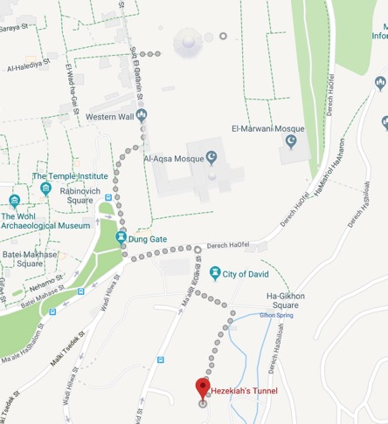

Day 11 - Jerusalem (3rd day)

Temple Mount
T
he current plateau in the middle of the Old City is known as Temple Mount. It was here that Herod’s magnificent Temple stood
with its golden exterior visible for miles.
This plateau is also known in the Bible as Mt. Moriah, and is the place where Abram offered Isaac to God (Genesis 22). It is also the place where David purchased the threshing floor (2 Samuel 24) and a sacrifice was offered to God who ended the plague. And it was on this
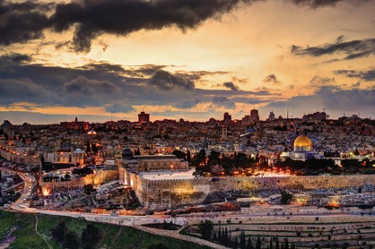
mountain that Jesus, the Lamb of God, was crucified for the sins of the world.
Originally, the area was a smaller mountain, upon which was built the village of Jerusalem. Over the centuries, as the city walls were expand- ed and the spaces filled in, the mountain has become the large plateau we know today.
Dome of the Rock and al-Aqsa Mosque: The Dome is the oldest ex- ample of early Islamic architecture and was built in 691 ad. It covers the foundation stone thought by Muslims to be the rock from which Mohammad ascended to heaven.
The al-Aqsa Mosque occupies the end of Temple Mount opposite the

Dome. Its name means “Farthest Mosque” and stems from its distance from Mecca. It is the 3rd most sacred mosque in Islam, and the 2nd oldest after the Ka’ba in Mecca.

City of David
The original inhabitants of Jerusalem lived not on the site of today’s Old City, but on a narrow ridge descending south from the present Temple Mount. This is where King David captured the fortress of a Canaanite tribe, the Jebusites, 1000 years before Christ. On this slen- der spur — about 5 hectares (12 acres) in area — David established his capital and pitched a tent to house the Ark of the Covenant. The site possessed the natural defences of the Hinnom valley to the south, the Kidron Valley to the east, and the Tyropoeon Valley (now largely filled in by the debris of centuries) to the west. And it had fresh wa- ter from the Gihon Spring gushing at its foot. Besides David and his son Solomon, this would have been the stomping ground of kings Hezekiah and Josiah and the prophets Isaiah and Jeremiah. Standing on the observation platform of the City of David archaeological park, it is easy to see how David could have looked down from the roof of his palace and spied the beautiful Bathsheba bathing (2 Samuel 11: 2).
(from seetheholyland.net)

Hezekiah’s Tunnel
Hezekiah’s Tunnel was cut through solid rock at the beginning of the 8th century B.C.. One of the most ingenious engineering accomplish- ments of ancient times, it bears testimony to the crucial importance of a water supply to Jerusalem.
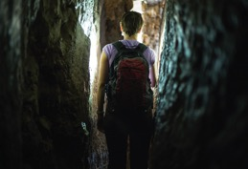

In times of war and siege, the City of David was vulnerable, since it depended on water from the Spring of Gihon. This spring, which
gushes forth intermittently from a natural cave in the Kidron Valley, was outside the city walls. King Hezekiah decided to bring water from the spring into the city. Following part of a natural fissure, two sets of teams began at opposite ends to cut a winding 533-meter tunnel on a double-S course — and they met in the middle. Axe and chisel marks can be seen along the entire length of the tunnel, which averages 60 centimeters wide and 2 meters high.
In 1880 a boy discovered an inscription in the rock near the mouth of the tunnel, which records its construction. Of the final breakthrough, it says: “While the laborers were still working with their picks, each toward the other, and while there were still three cubits to be broken through, the voice of each was heard calling to the other, because there was a crack in the rock to the south and to the north. At the moment of breakthrough, the laborers struck each toward the other, pick against pick. Then the water flowed”
Hezekiah’s Tunnel may be traversed on foot, best starting from the Spring of Gihon, outside the Dung Gate. A reliable torch is necessary and footwear is advisable. Water is generally knee-high but can rise to waist height.
(from seetheholyland.net)

Pool of Siloam
This is where Jesus ordered a blind man to go to wash mud out of his eyes and it lay undiscovered until 2004. Until then, a much smaller pool 50 meters north-west, at the end of Hezekiah’s Tunnel, had been regarded as the Pool of Siloam.
The account of the healing of the man who had been blind since birth (John 9:1-41) is one of the longest Gospel narratives of any of the miracles of Jesus. The disciples asked whose sin had caused the man’s blindness, his own or his parents? Neither, said Jesus; he was born blind “so that God’s works might be revealed in him”. Then Jesus spat on the ground, made mud with his saliva and spread the mud on the man’s eyes. “Go, wash in the Pool of Siloam,” he said. The man did as he was told, and he was able to see.
The rediscovered pool, was also fed by water from Hezekiah’s Tunnel, through a channel leading from the smaller pool. Coins found in the

cement show it was in use in Jesus’ time, when four sets of monumen- tal steps led from street level into the pool.
This property, now belonging to the Greek Orthodox Church, was once part of an orchard known as the King’s Garden. The building of a wall around the pool and the garden is recorded in Nehemiah 3:15.
(from seetheholyland.net)

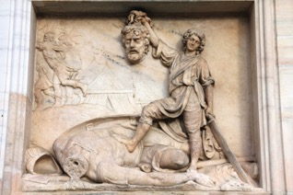
Valley of Elah
A valley in the Shephelah, between Azekah and Socoh, where David killed Goliath. The Valley of Elah is modern Wadi es-Sant.
Elah means “terebinth.” The Valley of Elah ran east to west between Israelite and Philistine territory, with Gath to the west, which made it a likely spot for a clash between the two powers. In 1 Samuel 17, the Israelite forces were probably on the hills on the north side of the valley, with the Philistines opposite them. (from Lexham Bible Dictionary)
Be sure to pick up five smooth stones in case you run into Goliath or his brothers.

Related Biblical References:
  - Gen 22:1-18 - Abraham on Mt. Moriah
  - 2 Sam 24:18-25 - David buys the land for the temple
  - 2 Sam 5:4-9 - David captures Jerusalem
  - 2 Kings 20:20 - Hezekiah builds pools and tunnel
  - Neh 3:15 - Wall built around the pool of Siloam

- John 9:1-10:21 - Jesus gives sight to a man born blind
- 1 Sam 17:1-58 - David & Goliath in the Valley of Elah

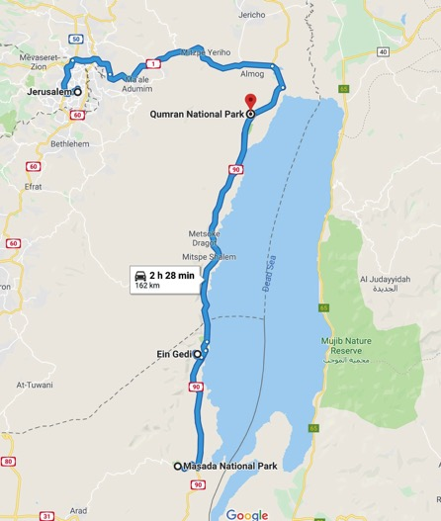

Day 12 - Masada, Qumran, Jericho

Masada
T
he rock top fortress of Masada overlooking the Dead Sea has been invested with a quasi-religious significance as a symbol of
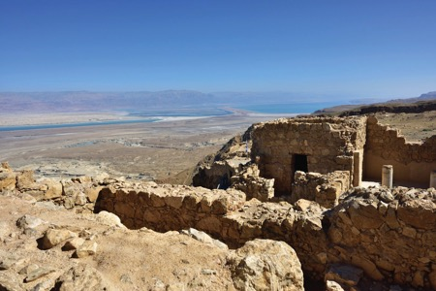
resistance for the people of Israel. Once a palatial refuge for Herod the Great, this massive plateau on the eastern edge of the Judean Desert is better known as the location of a Roman siege against Jewish rebels in AD 74.

The story of 960 defenders choosing self-inflicted death rather than surrender has achieved legendary status for the Jewish people, though scholars have questioned its credibility. Masada’s symbolic status was boosted by a poem by Yitzchak Lamdan, published in 1927, and by extensive excavations by soldier-archaeologist Yigael Yadin.
Masada’s summit may be reached by a tortuous “snake path” (which takes a fit person 45 minutes), by a path up the Roman siege ramp (15 minutes) or by a modern cable car. The view across the Dead Sea 450 meters below is spectacular. After Jerusalem, Masada is Israel’s most popular tourist attraction.

Herod planned Masada as a palace stronghold and desert foxhole, and fortified it with walls, gates and towers. He wanted a place of ref-
uge in case the Jews should rebel against him, or the Egyptian pharaoh Cleopatra (who coveted Judea) should try to have him killed.
To supply water in this arid setting, a sophisticated system channeled winter rainfall from nearby wadis into huge cisterns quarried low into the northwest of the mountain. Water was then carried by men and beasts of burden up winding paths to reservoirs on the summit. The lower cisterns alone are estimated to have a capacity of 38,000 cubic meters.
In AD 66, at the beginning of the Great Jewish Revolt against Rome, a group of Jewish extremists called Sicarii overran the Roman garrison stationed on Masada. By then, Herod had been dead for 70 years.
According to the historian Josephus, the Sicarii were unlikely heroes who attacked local villages. In a night raid for food on the Jewish settlement of En-Gedi, 17km away, he says the Sicarii killed more than 700 Jewish settlers, including women and children, during Passover.
The Roman governor Lucius Flavius Silva waited until Jerusalem had fallen before taking the Tenth Legion to Masada in 72-73. Laying siege to the fortress, he established eight fortified camps linked by a ditch and wall around Masada, then built a ramp on top of a natural bed- rock spur to reach the summit.
Up the ramp the Romans rolled an iron-sheathed siege tower, with rapid-firing catapults and a huge battering ram to breach the fortress wall. According to Josephus, when defeat was inevitable the leader of the Sicarii, Eleazar ben Ya’ir, gave two impassioned speeches persuad- ing his companions to cast lots to kill each other rather than be taken prisoner. (from seetheholyland.net)

Ein Gedi
On the shores of the Dead Sea, at the foot of the Judean Hills to the west, and facing the Mountains of Moab to the east, at the lowest spot on earth, nature has created thermo-mineral springs with healing properties found nowhere else. The Ein Gedi hot springs - a rare natu- ral phenomenon existing only in Israel
The name Ein Gedi is composed of two Hebrew words: ein means spring and gedi means goat-kid. En Gedi thus means “Kid spring.”

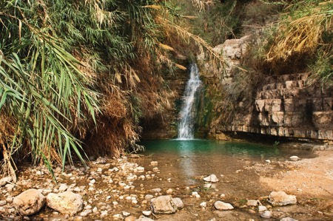
In the 2 Chron 20:2 it is identified with Hazazon-tamar, where the Moabites and Ammonites gathered in order to fight Jehoshaphat. In Genesis 14:7 Hazazon-tamar is mentioned as being an Amorite city, smitten by Chedorlaomer in his war against the cities of the plain.
In Joshua 15:62, Ein Gedi is enumerated among the cities of the Tribe of Judah in the desert Betharaba, but Ezekiel 47:10 shows that it was also a fisherman’s town. Later, King David hides in the desert of Ein Gedi and King Saul seeks him “even upon the most craggy rocks, which are accessible only to wild goats”. (from seetheholyland.net)

Qumran
This little known community in the Judean desert became world famous when a shepherd boy herding goats happened upon its vast storehouse of ancient texts.
Constructed 134-104B.C., this settlement was inhabited until being destroyed by the Romans in 68 ad. It is most famous for the Dead Sea Scrolls that were first found in one of the many caves that surround the site.
Our best sense of the inhabitants of Qumran is that they were a group of people very much dedicated to a strict lifestyle, and the belief in a coming Messiah. They were very diligent in the copying and preserv- ing of ancient texts, especially the Old Testament. Archaeologists have

discovered a large Scriptorium, or writing room, complete with rows of desks, where scribes and students spent hours copying the ancient texts.
They shared the common outlook of the Old Testament in worship- ing the God of their Fathers, and looking forward to the coming of Messiah. They considered themselves God’s Elect, and withdrew to the desert to “prepare the way of the Lord.” According to their own writings, they saw themselves as those with whom God had made a “New Covenant” (See: Jeremiah 31:31-34). Central to their faith was a passionate belief that the “last days” were at hand, when God would descend with his angels to wipe out all evil, sin, and opposition, and establish his Kingdom.
The Dead Sea Scrolls: Eleven caves clustered around the ruins of the ancient Qumran community have yielded manuscripts or fragments. Cave I was discovered in 1947 and the latest discovery, Cave XI, was found in 1956. Of the caves, Caves I and XI have produced relatively intact manuscripts, while Cave IV held the largest cache of manu- scripts: tens of thousands of fragments belonging to more than 380 manuscripts.
The manuscripts range from small pieces of pottery and parchment, to large vellum scrolls, and even a massive copper scroll 27 feet long. Evidence found in each cave demonstrated that the archaeologists were not the first to examine their contents. In every case, many manuscripts were damaged or missing. In several instances, scholars would arrive at a cave only to find local shepherds warming them- selves over the flames from burning parchment. But, the manuscripts which remain are enormously significant both for biblical studies, and as historical reminders of life in the Judean wilderness before and during the time of Christ.
The Dead Sea Scrolls are a collection of 972 texts from the Hebrew Bible. The texts are of great mystical and historical significance, as they include the oldest known surviving copies and extra-biblical docu- ments and preserve evidence of great diversity in late Second Temple Judaism. They are written in Hebrew, Aramaic and Greek, mostly on parchment, but with some written on papyrus. These manuscripts generally date between 150 B.C. and 70 AD.
While the discovery of the Scrolls has been beneficial to many areas of study, of primary interest to Christians has been their impact on

supporting the historical authenticity of the Bible.
The significance of the scrolls relates in a large part to the field of tex- tual criticism and how accurately the Bible has been transcribed over time. Before the discovery of the Dead Sea Scrolls, the oldest Hebrew manuscripts of the Bible were Masoretic texts dating to 10th century CE such as the Aleppo Codex. The biblical manuscripts found among the Dead Sea Scrolls push that date back a millennium to the 2nd cen- tury B.C.E. Before this discovery, the earliest extant manuscripts of the Old Testament were in Greek in manuscripts such as Codex Vaticanus Graecus (1209) and Codex Sinaiticus.
According to The Oxford Companion to Archaeology: “The biblical manuscripts from Qumran, which include at least fragments from ev- ery book of the Old Testament, except perhaps for the Book of Esther, provide a far older cross section of scriptural tradition than that avail- able to scholars before.”

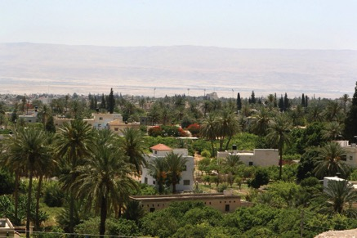
Jericho
Jericho is a city located near the Jordan River in the West Bank of the Palestinian Territories. It is the capital of the Jericho Governorate, and has a population of over 20,000. Situated well below sea level on an east-west route 10 miles north of the Dead Sea, Jericho is the lowest permanently inhabited site on earth. It is also believed to be one of the oldest continuously inhabited cities of the world. Described in the

Hebrew Bible as the “City of Palm Trees”, copious springs in and around Jericho have made it an attractive site for human habitation for thousands of years.
The Israelites witnessed God bring down its walls with their great shout and trumpet blasts. Here Jesus healed Bartimaeus, the blind beggar, and dined with Zacchaeus, the rich tax collector. And both Cleopatra and Herod the Great coveted this lush oasis.
Jericho (the name means “City of palms”) is mentioned 70 times in the Old Testament. In perhaps the most famous battle in the Bible, it was the first town captured by the Israelites when they entered the Promised Land.
Since Jericho was on the normal route from Galilee to Jerusalem, Jesus passed through it several times. Near the centre of the city, a centu- ries-old sycamore tree recalls the incident in which the tax collector Zacchaeus, too short to see over the crowd, climbed a sycamore’s branches in order to see Jesus.
Jesus chose the steep, rocky road from Jerusalem down to Jericho as the setting for the parable of the Good Samaritan. In this parable, Jesus describes the compassion of an alien (the Samaritan) towards a man who had been beaten and robbed, contrasting it with the pitiless attitude of a priest and a Levite who had “passed by on the other side” of the road. At that time, Jericho was one of the cities designated for the residence of priests and Levites rostered for duty in the Temple, about 28 km away. About 12,000 priests and Levites are believed to have lived there, and they were a familiar sight on the road.
In 35 B.C. the Roman politician Mark Antony made a gift of Jericho to his lover Cleopatra of Egypt. Cleopatra had coveted the oasis because she wanted to control the plantations of persimmon (now extinct), which produced a perfume that reputedly “drove men wild”. Later Cleopatra leased Jericho to Herod the Great at an exorbitant fee that cost him almost half Judea’s income.
After Mark Antony and Cleopatra died, Herod gained ownership of the city. He built a palatial residence and died there in 4 B.C..
(from seetheholyland.net)

Wadi Qelt
This is a wadi or valley within the Jordan Valley one mile south

of Jericho, and near the Dead Sea in the West Bank, part of the Palestinian territories. It is said to be the winter home of King Herod. This is the general area in which Christ retreated to fast and pray for 40 days. It is also the location of His three temptations by Satan. This is often referred to the Valley of the Shadow of Death as spoken of in Psalm 23.

Related Biblical References:
- 2 Chron 20:1-4 – Moabites and Ammonites gathered for war
- 1 Sam 24:1-22 - David hiding from Saul in Engedi
- Jeremiah 31:31-34 - Prophecy concerning the New Covenant
- Joshua 6:1-21 - Joshua captures Jericho
- 2 Kings 2:15-22 - Elisha purifies the spring
- Luke 19:1-10 - Zacchaeus meets Jesus
- Mark 10:46-52 - Jesus heals Bartimaeus
- Luke 10:25-37 - The Good Samaritan
- Psalm 23 - The Valley of the Shadow of Death
- Luke 4:1-13 - Jesus tempted by Satan in the wilderness

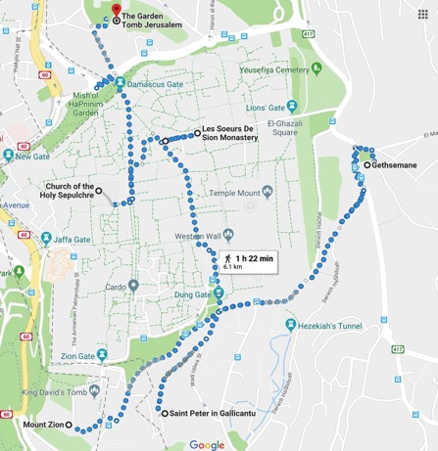

Day 13 - Jerusalem (4th day)

Upper Room
Also known as The Cenacle (Latin: cenaculum, from cena meaning supper) this is the traditional site of the Last Supper. This large upper room was probably part of the home of Mark’s parents, and was also the site where the Apostles often gathered. It was here that Jesus and His disciples ate the final Passover, where Jesus washed the disciples’ feet, where Judas was identified as the betrayer, where the Apostles later gathered after the resurrection, where Matthias was elected to join their number, and where the Holy Spirit descended on Pentecost. People marvel at its exquisite architecture.
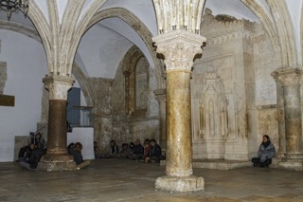

House of Caiaphas
Caiaphas was High Priest when Jesus was arrested and it was to his house that Jesus was first taken for what would be the first trial
(Matthew 27:57ff). It was also here, in the outer courtyard, that Peter’s three denials took place (Matthew 26:69 ff). Today a church - St. Peter in Gallicantu which means “the crowing of the cock - is built over the remains of the house, which include the original dungeon located deep below the house, in which Jesus spent the night following His ar- rest. Today the dungeon is open and lit, but originally it was accessible only through a hole in the top of a hollowed out space in the rock.

Church of all Nations
The Church of All Nations, standing near the foot of the Mount of Olives in Jerusalem, is built over the rock on which Jesus is believed to have prayed in agony the night before he was crucified. The church and the adjacent Garden of Gethsemane, with its eight ancient olive trees, provide an evocative place for meditation, especially when vis- ited at night. The church is also known as the Basilica of the Agony... The richly-colored triangular mosaic at the top of the facade makes it a Jerusalem landmark.
The basilica is called the Church of All Nations because many countries contributed to the cost of construction.
(from seetheholyland.net)

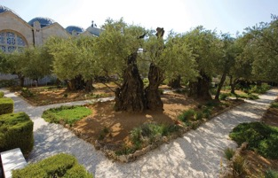
Garden of Gethsemane
Located at the foot of the Mt. of Olives, this garden is the place Jesus and His disciples came on the night He was betrayed. Both Matthew and Mark refer to this as a place or estate while John calls it a garden. Jesus and His disciples were regular visitors to this beautiful spot, and you’ll see why. It is quiet and the perfect place for reflection and prayer. Overlooking the Garden is the Church of All Nations, also known as the Church of the Agony. Nearby is the Russian Orthodox Church of St. Mary Magdalene with its eye-catching golden domes.

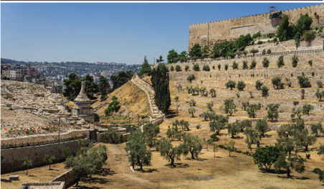
Kidron Valley
The Kidron Valley, a place of olive groves, ancient tombs and mis- named funerary monuments, divides Jerusalem’s Temple Mount from the Mount of Olives. Once a deep ravine channeling a seasonal stream, it provided a defensive border to the original City of David — and a route to the wilderness for King David when he fled from his rebel- lious son Absalom.
Jesus often traversed the Kidron on his way to the village of Bethany, his favorite place of rest and refuge. After the Last Supper, he crossed the valley with his disciples to the garden of Gethsemane. Then, after he was betrayed, he was brought back the same way to the house of the high priest.
By the light of the Passover moon, the whitewashed tombs cut into the valley’s rock-face would have provided a stark reminder to Jesus that on the following day his own body would be laid in a tomb. Since the 4th century, an identification of the Kidron with the Valley of Jehoshaphat (a name meaning “Yahweh shall judge”) mentioned in the book of Joel (3:2,12) has led to the belief that it will be the place of final judgment.
Across the street from the Church of All Nations at Gethsemane, a paved path leads southward to the floor of the Kidron Valley. On the right is the Greek Orthodox Church of St Stephen. On the right looms the wall of the Temple Mount, with the sealed double portals of the Golden Gate standing out. On the left, the world’s largest Jewish ceme-

tery stretches up the Mount of Olives. The cemetery’s location follows the Jewish belief that the long-awaited Messiah will pass through the Golden Gate to begin the resurrection of the dead. In reaction to this belief, Muslims established a cemetery in front of the gate to block the Messiah’s path — and this may also be why the Ottoman ruler Suleiman the Magnificent sealed the gate in 1541.
The Golden Gate may have been where Jesus entered the city on Palm Sunday. It was probably also the Beautiful Gate of Acts 3:1-10, where the apostle Peter healed a lame beggar. (from seetheholyland.net)

Via Dolorosa
Via Dolorosa (“Way of Grief” in Latin) is a road in the old city of Jerusalem, a path where Jesus was lead in agony, carrying the cruci- fixion cross. There are a total of 14 stations along this path, based on events that occurred on the way to the Golgotha hill, the site of cruci- fixion, which is located at the Church of the Holy Sepulcher. Eight sta- tions are marked along the old city road, while six additional stations are places in the compound of the church.
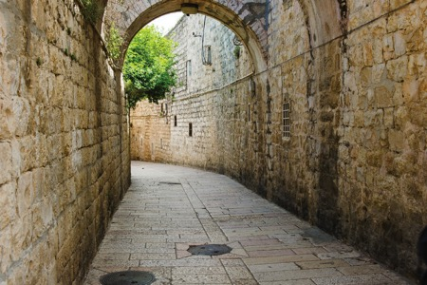

Judgment Hall

The second station is in the street below, where, at the foot of the Scala Santa, which led to the Judgment Hall, the cross was laid upon

Christ. A few paces westward the street is spanned by the Ecce Homo Arch . . . which marks the spot where Pilate brought Jesus forth “wear- ing the crown of thorns and the purple robe,” and presented Him to the multitude with the memorable words, “Behold the man!” (John 19:5). The arch has all the appearance of a Roman triumphal arch of the time of Hadrian. It consists of a large central arch, with a smaller one on the north side which has been included in and forms the east- ern termination of the Church of the Convent of the Sisters of Sion.
(from BiblePlaces.com)

Church of the Holy Sepulcher
The Church of the Holy Sepulcher in the Old City of Jerusalem covers what Christians believe is the site of the most important event in hu- man history: The place where Jesus Christ rose from the dead. But the pilgrim who looks for the hill of Calvary and a tomb cut out of rock in a garden nearby will be disappointed.
At first sight, the church may bring on a sense of anticlimax. Looking across a hemmed-in square, there is the shabby facade of a dun-col- ored, Romanesque basilica with gray domes and a cut-off belfry... This is the preeminent shrine for Christians, who consider it the holiest place on earth. And it attracts pilgrims by the thousand, all drawn to pay homage to their Saviour, Jesus Christ.
Early Christians venerated the site. Then the emperor Hadrian covered it with a pagan temple. Only in AD 326 was the first church begun by the emperor Constantine I. He tore down the pagan temple and had Christ’s tomb cut away from the original hillside. Tradition says his mother, St Helena, found the cross of Christ in a cistern not far from the hill of Calvary.
Constantine’s church was burned by Persians in 614, restored, de- stroyed by Muslims in 1009 and partially rebuilt. Crusaders completed the reconstruction in 1149. The result is essentially the church that stands today.
Visitors may easily be disillusioned by the church’s contrasting archi- tectural styles, its pious ornamentation and its competing liturgies. If these man-made elements could be removed, as biblical scholar John
J. Kilgallen has written, “we would stand between two places not more than 30 yards [90 feet] apart, with dirt and rock and grass under our feet and the open air all around us. Such was the original state of this

area before Jesus died and was buried here.”
But is this the place where Christ died and was buried? “Very prob- ably, Yes,” declares biblical scholar Jerome Murphy-O’Connor in his Oxford Archaeological Guide The Holy Land. Eusebius, the first
Church historian (in the 4th century), says the site was venerated by the early Christian community... One major objection raised is that the Church of the Holy Sepulcher is inside the city walls, while the Gospels say the crucifixion took place outside. Archaeologists have confirmed that the site of the church was outside the city until about 10 years after Christ’s death, when a new wall was built. Some favor a competing site, the Garden Tomb. Though it offers a more serene envi- ronment, the tombs in its area predate the time of Christ by several centuries. (from seetheholyland.net)

Garden Tomb
In a setting of neatly maintained gardens and trees, the Garden Tomb provides a tranquil environment for prayer and reflection. But doubts exist about the authenticity of claims that this is where Christ was buried and rose from the dead.
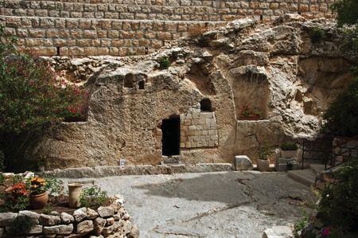
The open tomb carved into a rock face, with skull-like erosion in a limestone cliff nearby, can be found down an alley off Nablus Road, north of the Damascus Gate in Jerusalem. The site is particularly fa-

vored by Protestant pilgrims, in preference to the cluttered Church of the Holy Sepulcher in the Old City.
For a period it enjoyed the formal support of the Anglican Church. “It is much easier to pray here than in the Holy Sepulchre,” writes Jerome Murphy-O’Connor in his Oxford Archaeological Guide The Holy Land. “Unfortunately there is no possibility that it is in fact the place where Christ was buried.” The Nablus Road site of the Garden Tomb was first proposed in 1842 by a German scholar, Otto Thenius. He suggested that the skull-faced cliff was the hill of Golgotha, where Jesus was crucified. John’s Gospel (19:17) describes the place of cruci- fixion as “The Place of the Skull, which in Hebrew is called Golgotha”. The rock-hewn tomb nearby was found in 1867.
The main advocate of this site was a British army officer and adminis- trator, Major-General Charles Gordon, who visited Jerusalem in 1882-
- Though he had no academic education in history or archaeology, a dream assisted him to identify the cliff as the place where Jesus was crucified. For years the site was known as “Gordon’s Calvary”, Calvary being Latin for Golgotha. The idea that the “Place of the Skull” was named because of a skull-like hill is a modern notion. Most early Christian commentators held that Golgotha was so named because
it was a place of execution, where criminals’ skulls and bones lay scattered.
The Gospels do not reveal the precise location of Golgotha or Christ’s sepulcher. They do say that: • Christ was crucified near (but outside) the city and by a well-traveled road (since passersby mocked him). • He was buried in a new tomb, hewn out of rock, in a nearby garden. The Garden Tomb is certainly outside the walls of the Old City. The Church of the Holy Sepulcher, however, is inside the walls — but it was outside until about a decade after the crucifixion of Christ, when the so-called third north wall was built by Herod Agrippa I.
The present 16th-century battlements, constructed by the Turkish sultan Suleiman the Magnificent, follow the course of this 1st-century wall. This fact was not known in General Gordon’s time. All the tombs in the Garden Tomb area date from 7 to 9 centuries B.C. — the time of Jeremiah or Isaiah, rather than Jesus. But the tombs within the Church of the Holy Sepulcher were new in the time of Jesus.
The Church of the Holy Sepulcher also has longstanding tradition in its favor, indicating that it stands over the sites that the early Christian

community venerated as the places where Christ died, was buried and rose again. The Garden Tomb site, on the other hand, was used by Christian Crusaders as a stable.
Despite its lack of authenticity, the Garden Tomb has an aura of calmness that encourages meditation. “Walk around the gravel paths between the simple flower beds and the shrubs, and under the dark pines,” writes biblical historian E. M. Blaiklock. “Go one by one or two by two into the tomb, and pray for what lies nearest to the heart. A ser- vice is not necessary. It is a place in which you should meet with God alone, quietly, without distracting words, in tranquility.”
(from seetheholyland.net)

Related Biblical References:
  - Matthew 26:17-30; Luke 22:7-23 - The Last Supper
  - 1 Cor 11:23-26 - The Lord’s Supper
  - Acts 1:12-14; 2:1-4 - First believers meeting together; The coming of the Holy Spirit
  - John 18:12-14; Matt 26:57-75 - Jesus arrested; Peter’s denial
• Matthew 26:36-46; Mark 14:32-42; Luke 22:39-46; Mark 32-42 - Jesus prays in Gethsemane
• Matthew 26:47-56; Mark 14:43-50; Luke 22:47-53; John 18:1-12
    - Jesus is arrested
  - 2 Samuel 15:22-24 - King David flees from Absalom
  - Joel 3:2,12 - Judgment in the Valley of Jehoshaphat
  - Matthew 21:1-11 - Jesus enters the city on Palm Sunday
  - John 18:1 - Jesus crosses the Kidron Valley
  - Acts 3:1-10 - Peter heals a lame man at the Beautiful Gate
  - John 19:1-16 - Jesus brought out and condemned by Pilate
• Matthew 27:27-56; Mark 15:16-41; Luke 23:26-49; John 19:16-37
    - The crucifixion
• Matthew 27:57-66; Mark 15:42-47; Luke 23:50-56; John 19:38-42
    - The burial of Jesus
• Matthew 28:1-10; Mark 16:1-8; Luke 24:1-12; John 20:1-10 - The Resurrection

Rome, Italy

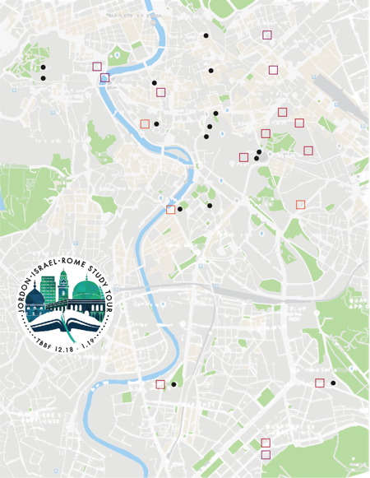
Spanish Steps 17

Vatican City 17
Sistine Chapel 17
Piazza Navona 17

Trevi Fountain 17

Trajan's Column 16
Insula Roman of San Paolo alla Regola 15 Piazza del Campidoglio 16
Capitoline Hill 16

Arch of Contantine 16

Colosseum 16

Aventine Hill 15

Parrocchia Santa Prisca 15

ROME, ITALY

Basilica Papale San Paolo fuori le Mura 16
Catacombe Domitilla 16

Complex Three Fountains Abbey 16
Basilica di San Giovanni in Laterano 17

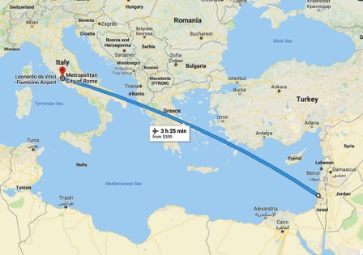

Ostia Antica
Day 14 - Fly to Rome (1st day)

eparting from Tel Aviv we will arrive at Rome’s international airport. Before we start the visit of Rome, we drive for approxi-
D
mately 10 minutes towards the sea, to visit the site of Ostia Antica the harbor city of Ancient Rome. We explore the well preserved excava- tions and step back in time into Roman antiquity. Ostia was a cosmo- politan city, which is reflected with the various temples dedicated to Mitra ( Persian) Cibele ( Turkish ), Iside ( Egyptian) and even a synagogue. No better place to understand that Rome was the right place for Christianity to start being a worldwide religion.
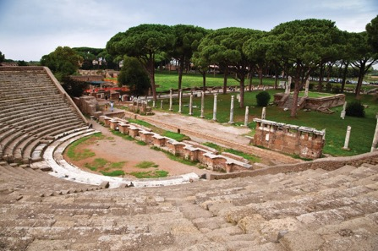

House on Aventino Hill

On the way to Rome, we continue with our tour: we will be remind- ed of the early companions of Paul, traveling to the Church of Santa Prisca dedicated to Santa Prisca on the Aventino Hill. Prisca came from a rich Roman family and Aquila, her husband was probably Greek. Paul spent a couple of years with them in Corinth and this is very often mentioned in his Letters and the Book of Acts.
The Church of Santa Prisca was erected in the end of the 4th centu-
ry-beginning of the 5th century on the site of the House of Aquila and

Prisca, celebrated husband and wife, who hosted Peter in their “eccle- sia domestica” where the apostle baptized different people. The ded- ication to Prisca could be attributed to two personalities: the owner of the house and a 13-year-old virgin martyr, who was considered a daughter of Aquila and Prisca.
The interior presents a plan with three naves delimited by two rows of seven Ionian columns, which are embodied into seventeenth-century pilasters. To the right is the baptismal tub where, according to tradi- tion, Peter baptized Prisca.
The excavations that began in 1934 have led to the retrieval of a Roman house from the 1st Century AD, probably where Aquila and Priscilla used to live.
Paul wrote in Rom 16:3-5 “Greet Prisca and Aquila, my fellow workers in Christ Jesus, who for my life, laid down their own necks; to whom not only I give thanks, but also all the assemblies of the Gentiles. Greet the assembly that is in their house.” The House on the Aventino Hill where Paul lived is named in a legal document of the 5th century, as “Titulus Priscae.”

Insula Di San Paolo alla Regola
We continue following the steps of St Paul recalling both his first and second visits to the city. We will begin our visit to the Insula Di San Paolo alla Regola. According to tradition, S. Paolo Alla Regola is the most accredited hypothesis of the first home of Paul in Rome. Here he lived between 61 and 63 AD, for eighteen months as required by law, pending trial. In this first Roman period, in his state of semi-freedom, Paul may have met the community of Rome, “domus ecclesiae” where they gathered to share the Word and the Eucharist and may have visit- ed the house of Aquila and Priscilla.
Paul lived in one of the places inhabited by the Jews, near the River Tiber, the Trastevere area, beyond the port of Ripa Grande, the 14th and final quarter of the city, according to the division of Augustus. Recent archaeological excavations in this zone showed the presence of stores of grain (horreum) and a second-century apocryphal ancient states, in fact, that “Paul took a rented horreum – A large barn where
you think you could preach, teach, comfort the Christians.” As the ma- jority of the people living there, Paul worked as a leather tanner. This area became known by the name of “Contrada Pauli” ( Paul’s district)

In a legal document of the year 1245, we find the words “ In loco qui dicitur Pauli” (In that place called “of Paul”). In 366 AC, Pope Damaso wanted to build a church over the ruins and dedicated it to Paul.
Visiting the church, you will see the oratory which has been created using the room where Paul lived and on the main beam you can read the following: “This is the place where the Apostle Paul lived and taught.”

Biblical References
Acts 18:1-28 - Paul meets and works with Priscilla & Aquila
Romans 16:3-5; 1 Cor 16:19 - Paul mentions Priscilla and Aquila with a church in their home.
Acts 28:11-31 - Paul arriving in Rome

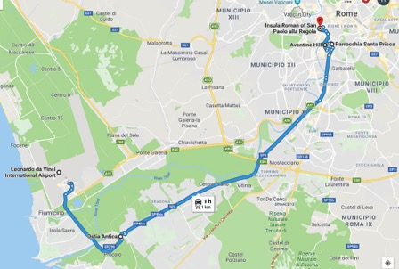

Day 15 - Rome (2nd day)

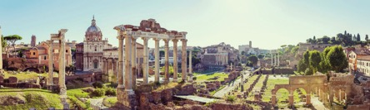
oday’s tour will show the great “power” of Rome and Emperors who demanded divinity for themselves. This was mainly where
the Apostle Paul preached against this is Romans 1:25 “and wor- shiped and served the creature more than the Creator, who is blessed forever.”
T

Trajan’s Column and Forum
From the Trajan’s Column, jewel of architecture and sculpture made by Apollodorus of Damascus, our guide
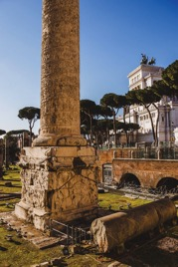
will show you along the Via dei Fori Imperiali (street of the Imperial Fora), the ruins of the fori that the great emperors built as lasting memory of their power. We see the Forum of Trajan, the biggest and most splendid of all, whose markets, true forerunners of the modern commercial centers, offered to the Roman citizen any goods to be found at that time.

Mamertine Prison
The Mamertine Prison, in antiqui-
ty the Tullianum, was a prison located in the Comitium in ancient Rome. It was situated on the northeastern slope of the Capitoline Hill. The church of San Giuseppe dei Falegnami now stands above the Mamertine.
According to tradition, the prison was constructed around 640–616

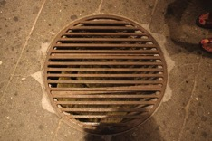
B.C., by Ancus Marcius. It was originally created as a cistern for a spring in the floor of the second lower level. Prisoners were lowered through an opening into the lower dungeon. Incarceration in facilities such as the Tullianum was intended to be a temporary measure prior to trial or execution.

It has been long referenced that St. Peter was imprisoned at the Tullianum. Saint Paul’s imprisonment is well referenced by his Roman citizenship and decree of execution by Nero.

Capitoline Hill - Piazza del Campidoglio - Roman Forum
On foot you will reach the Capitoline Hill, once political and religious center of the town, which today is the seat of the Municipality. The stairway will lead you to the Piazza del Campidoglio, the magnificent result of a single project by Michelangelo, with a copy of the most fa- mous equestrian statue in the world, the statue of Marcus Aurelius, in the middle. Behind Piazza del Campidoglio you will find a natural ter- race providing the best panoramic point over the valley of the Roman Forum and the Palatine Hill. Walking through the valley of the Roman Forum the great Rome with its important buildings will revive before your eyes; the Curia, seat of the Roman Senate, the State Archive, the basilicas, palaces of justice, the temple of Vesta, and the House of the Vestals, the virgins in charge of keeping the sacred fire always alive, and all around temples and columns and arches of triumph erected to commemorate gods of Roman history.
From the Forum the guide will show you to the place linked to the fabulous origins of Rome: the Palatine. Here Romolus founded the town in the year 753 B.C. and starting with Augustus the great emper- ors settled here. From the valley of the Roman Forum you will admire the Domus Tiberiana only partially explored and the ruins of the Imperial Palaces.

Roman Colosseum
Leaving the Roman Forum you will find the Arch of Constantine, erected to commemorate the victory of the emperor over Maxentius in the 4th century A.D. (tradition says that before the battle the Emperor saw a brilliant cross in the sky and said the famous words “in hoc signo vinces”). The tour ends at the Colosseum, everlasting symbol of the greatness of Rome and the stage for the historical fights of the gladiators.
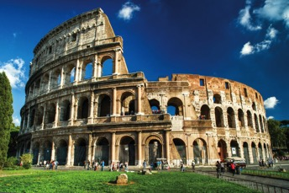

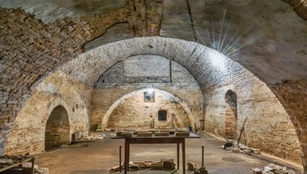
Catacombs of Santa Domotilla
Continue on the Ancient Appian Way, to visit the Catacombs of Santa Domitilla. The Christian catacombs are extremely important for the art history of early Christians. At first they were used both for burial and the memorial services and celebrations of the anniversaries of Christian martyrs (following similar Roman customs). They probably

were not used for regular worship. Many modern depictions of the catacombs show them as hiding places for Christian populations during times of persecution.

Abbey of the Three Fountains
Regain our bus and continue the tour visiting Abbey of the Three Fountains, the place of Paul’s martyrdom, where tradition has it that three different springs gushed out at each spot touched when Paul’s head fell down. Legend claims that when St Paul was decapitated, his head bounced three times and fountains miraculously sprang out when it touched the ground. The legend is nice, but the springs were known in pre-Christian times as the Aquae Salviae, and the excava- tions revealed ancient mosaic pavements. Still, even if it is not true it helps identify the site of St Paul’s martyrdom. It is also said that there was a stone-pine tree at the site of his death, and the identification
of this place was strengthened when ancient stone-pine cones were found here during excavations in 1857.

Basilica of St. Paul outside the walls
To conclude this day in Rome we will visit the place where the bones of Paul have recently been found, Basilica of St. Paul Outside the Walls. It is a Benedictine Abbey which shares its name, origins and centuries of history, both joyful and sorrowful, with the adjoining basilica.

Biblical References
Romans 1:18-32 - Paul speaking against the rebellious man
1 Peter 1:3-9 - Peter’s encouragement to believers going through se- vere persecution
Col 4:18 - Paul requesting that believers remember him as he is in prison in Rome

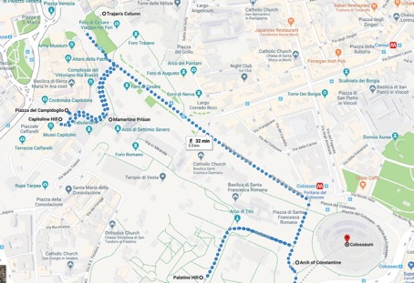
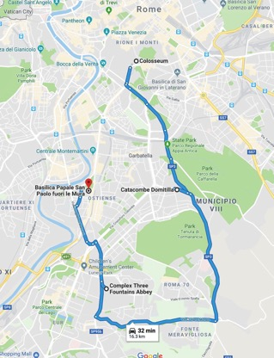

Day 16 - Rome (3rd day)
aul was not the only Apostle of the early church associated with Rome. Peter was martyred on the Vatican Hill and the memory of
P
the impact of the Apostle John’s lasting ministry before and after his apparent arrest and exile to Patmos by Emperor Domitian also has its place. This morning we board our bus and continue our Roman visit at Basilica of St John in Lateran which became among the most im- portant Christians Churches of Rome.
We continue with a relaxing walking tour throughout the most beau- tiful squares of Rome, from the Trevi Fountain, to the Pantheon and Navona Square, where we will enjoy a break for lunch. In the after- noon we will visit the imposing Vatican Museums and Sistine Chapel.

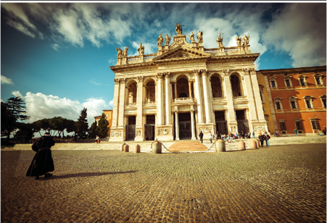
Basilica of St. John in Lateran
When Constantine opened the Roman world to Christianity, his apparent conversion was symbolized by the donation of a significant family property for the Basilica. The important Lateran Baptistery reminds us of the many early converts to the faith and the process of moving it from a rogue influence to a sponsored and ordered faith.
The cathedral, rises from the same place where the basilica of

Costantino was erected round 314. The ancient basilica had four aisles for nearly one thousand years was the most important church of Christianity, the centre of Pope’s power and residence of the Pontiff.

Holy Stairs
In 1510, Luther was sent to Rome, where he witnessed the corruption of the Roman church. He climbed the
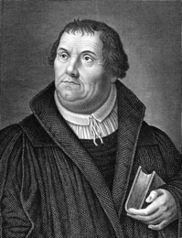
Scala Sancta (“The Holy Stairs”), supposedly the same stairs Jesus ascended when He appeared before Pilate. According to fables, the steps had been moved from Jerusalem to Rome, and the priests claimed that God forgave sins for those who climbed the stairs on their knees.
Luther did so, repeating the Lord’s Prayer, kissing each step, and seeking peace with God. But when he reached the top step, he looked back and thought, “Who knows whether this is true?.” He felt no closer to God. (by Steve Lawson)

Trevi Fountain
The Trevi Fountain is a fountain in the Trevi district, designed by Italian architect Nicola Salvi and completed by Giuseppe Pannini. Standing 86 ft high and 161.3 ft, it is the largest Baroque fountain in the city and one of the most famous fountains in the world. The foun- tain has appeared in several notable films.

Navona Square and the Pantheon
Piazza Navona is built on the site of the Stadium of Domitian, built in the 1st century AD, and follows the form of the open space of the sta- dium. The ancient Romans went there to watch the agones (“games”), and hence it was known as “Circus Agonalis” (“competition arena”).
The Pantheon “temple of all the gods” is a former Roman temple, now a church, on the site of an earlier temple commissioned by Marcus Agrippa during the reign of Augustus (27 B.C. – 14 AD). It was com- pleted by the emperor Hadrian and probably dedicated about 126 AD.

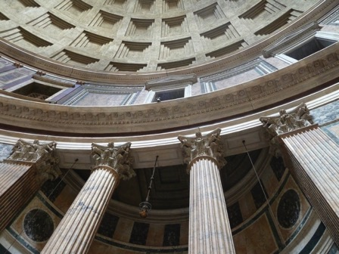

The building is circular with a portico of large granite Corinthian columns (eight in the first rank and two groups of four behind) under a pediment. A rectangular vestibule links the porch to the rotunda, which is under a coffered concrete dome, with a central opening (oculus) to the sky. Almost two thousand years after it was built, the Pantheon’s dome is still the world’s largest unreinforced concrete dome. The height to the oculus and the diameter of the interior circle are the same, 142 ft.
It is one of the best-preserved of all Ancient Roman buildings, in large part because it has been in continuous use throughout its history, and since the 7th century, the Pantheon has been used as a church dedicat- ed to “St. Mary and the Martyrs.”

Vatican City
Vatican City is an independent city-state enclaved within Rome, Italy. Established with the Lateran Treaty (1929), it is distinct from yet un- der “full ownership of the Holy See .” With an area of 110 acres, and a population of about 1,000, it is the smallest state in the world by both area and population.
The Vatican City is an ecclesiastical or sacerdotal-monarchical state (a

type of theocracy) ruled by the pope who is, religiously speaking, the bishop of Rome and head of the Catholic Church. Since the return of the popes from Avignon in 1377, they have generally resided at the Apostolic Palace within what is now Vatican City, although at times residing instead in the Quirinal Palace in Rome or elsewhere.
Within the Vatican City are religious and cultural sites such as St. Peter’s Basilica, the Sistine Chapel and the Vatican Museums. They feature some of the world’s most famous paintings and sculptures.

Vatican Museums
The Vatican Museums are Christian and art museums located with- in the city boundaries of the Vatican City. They display works from the immense collection amassed by popes throughout the centuries including several of the most renowned Roman sculptures and most
important masterpieces of Renaissance art in the world. The museums contain roughly 70,000 works, of which 20,000 are on display, and currently employ 640 people who work in 40 different administrative, scholarly, and restoration departments.
Pope Julius II founded the museums in the early 16th century. It is one of the largest museums in the world.

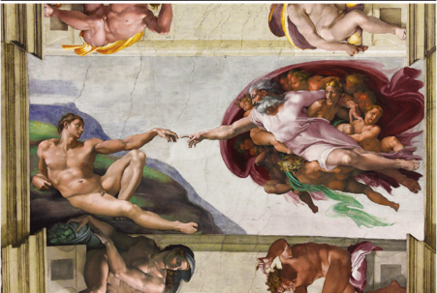
Sistine Chapel
The Sistine Chapel is a chapel in the Apostolic Palace, the official

residence of the Pope, in Vatican City. Originally known as the Cappella Magna, the chapel takes its name from Pope Sixtus IV, who restored it between 1477 and 1480. Since that time, the chapel has served as a place of both religious and functionary papal activity.
Today it is the site of the Papal conclave, the process by which a new pope is selected. The fame of the Sistine Chapel lies mainly in the frescos that decorate the interior, and most particularly the Sistine Chapel ceiling and The Last Judgment by Michelangelo.
During the reign of Sixtus IV, a team of Renaissance painters that included Sandro Botticelli, Pietro Perugino, Pinturicchio, Domenico Ghirlandaio and Cosimo Rosselli, created a series of frescos depicting the Life of Moses and the Life of Christ, offset by papal portraits above and trompe l’oeil drapery below. These paintings were completed in 1482.
Between 1508 and 1512, under the patronage of Pope Julius II, Michelangelo painted the chapel’s ceiling, a project which changed the course of Western art and is regarded as one of the major artistic accomplishments of human civilization. In a different climate after the Sack of Rome, he returned and between 1535 and 1541, painted The Last Judgment for Popes Clement VII and Paul III. The fame of
Michelangelo’s paintings has drawn multitudes of visitors to the chapel ever since they were revealed five hundred years ago.

Biblical References
Romans 1:17; 3:20; 6:23 - Salvation as a free gift of God through faith, not by works

Chorus
10,000 reasons (Bless the Lord)

Bless the Lord, Oh my soul
Oh my soul, worship his holy name Sing like never before, Oh my soul I’ll worship your holy name

Verse 1
The sun comes up, it’s a new day dawning It’s time to sing your song again
Whatever may pass and whatever lies before me Let me be singing when the evening comes

Verse 2
You’re rich in love and you’re slow to anger Your name is great and your heart is kind For all your goodness, I will keep on singing Ten thousand reasons for my heart to find

Verse 3
And on that day when my strength is failing The end draws near and my time has come Still my soul will sing your praise unending Ten thousand years and then forevermore Forevermore

Verse 1
All I Have Is Christ

I once was lost in darkest night
Yet thought I knew the way
The sin that promised joy and life Had led me to the grave
I had no hope that You would own A rebel to Your will
And if You had not loved me first I would refuse You still

Verse 2
But as I ran my hell-bound race Indifferent to the cost
You looked upon my helpless state And led me to the cross
And I beheld God’s love displayed You suffered in my place
You bore the wrath reserved for me Now all I know is grace

Chorus
Hallelujah all I have is Christ Hallelujah Jesus is my life

Verse 3
Now Lord I would be Yours alone And live so all might see
The strength to follow Your commands Could never come from me
O Father use my ransomed life In any way You choose
And let my song forever be My only boast is You

Verse 1
All To Us

Precious cornerstone, sure foundation
You are faithful to the end We are waiting, on You, Jesus We believe You’re all to us

Chorus
Let the glory of Your name be the passion of the Church Let the righteousness of God be a holy flame that burns Let the saving love of Christ be the measure of our lives We believe You’re all to us

Verse 2
Only Son of God sent from Heaven Hope and mercy at the cross
You are everything, You’re the Promise Jesus You, are all to us

Bridge
You’re all to us You’re all to us You’re all to us Yes you are

Verse 3
When this passing, world is over We will see You, face to face And forever, we will worship Jesus You, are all to us
Jesus You, are all to us

Verse 1
And Can It Be
Verse 4

And can it be that I should gain An interest in the Savior’s blood
Died He for me who caused His pain For me who Him to death pursued Amazing love how can it be
That Thou my God shouldst die for me
Amazing love how can it be
That Thou my God shouldst die for me

Verse 2
‘Tis mystery all th’Immortal dies Who can explore His strange design In vain the firstborn seraph tries
To sound the depths of love divine ‘Tis mercy all let earth adore
Let angel minds inquire no more ‘Tis mercy all let earth adore
Let angel minds inquire no more

Verse 3
He left His Father’s throne above So free so infinite His grace Emptied Himself of all but love And bled for Adam’s helpless race ‘Tis mercy all immense and free For O my God it found out me ‘Tis mercy all immense and free For O my God it found out me
Long my imprisoned spirit lay
Fast bound in sin and nature’s night Thine eye diffused a quickening ray I woke the dungeon flamed with
light
My chains fell off my heart was free I rose went forth and followed Thee My chains fell off my heart was free I rose went forth and followed Thee

Verse 5
No condemnation now I dread Jesus and all in Him is mine Alive in Him my living Head
And clothed in righteousness divine Bold I approach th’eternal throne And claim the crown through Christ
my own
Bold I approach th’eternal throne And claim the crown through Christ
my own

Verse 1
Blessed Be Your Name

Blessed Be Your Name

In the land that is plentiful
Where Your streams of abundance flow Blessed be Your name

Verse 2
Blessed Be Your name
When I’m found in the desert place Though I walk through the wilderness Blessed Be Your name

Pre-Chorus
Every blessing You pour out, I’ll turn back to praise When the darkness closes in, Lord, Still I will say

Chorus
Blessed be the name of the Lord Blessed be Your name
Blessed be the name of the Lord Blessed be Your glorious name

Verse 3
Blessed be Your name
When the sun’s shining down on me When the world’s ‘all as it should be’ Blessed be Your name

Verse 4
Blessed be Your name
On the road marked with suffering Though there’s pain in the offering Blessed be Your name

Bridge
You give and take away, You give and take away
My heart will choose to say, Lord blessed be your name Come Praise And Glorify

Verse 1
Come Praise and Glorify

The Father of our Lord
In Christ He has in heav’nly realms His blessings on us poured
For pure and blameless in His sight He destined us to be
And now we’ve been adopted through His Son eternally

Chorus 1
To the praise of Your glory
To the praise of Your mercy and grace To the praise of Your glory
You are the God who saves

Verse 2
Come praise and glorify our God Who gives His grace in Christ
In Him our sins are washed away Redeemed through sacrifice
In Him God has made known to us The myst’ry of His will
That Christ should be the head of all His purpose to fulfill

Verse 3
Come praise and glorify our God For we’ve believed the Word
And through our faith we have a seal The Spirit of the Lord
The Spirit guarantees our hope Until redemption’s done
Until we join in endless praise To God the Three in One

Verse 1
Lord of all creation
Of the water, earth and sky

God of Wonders

The Heavens are Your Tabernacle Glory to the Lord on high

Chorus
God of wonders, beyond our galaxy You are holy, holy
The universe declares Your majesty You are holy, holy
Lord of Heaven and Earth Lord of Heaven and Earth

Verse 2
Early in the morning
I will celebrate the light
And when I stumble into darkness I will call Your name by night

Bridge
Hallelujah to the Lord of heavens and earth Hallelujah to the Lord of heavens and earth Hallelujah to the Lord of heavens and earth

Verse 1
When the music fades All is stripped away And I simply come Longing just to bring
Something that’s of worth That will bless your heart

Pre-Chorus
Heart of Worship

I’ll bring you more than a song
For a song in itself
Is not what you have required You search much deeper within Through the way things appear You’re looking into my heart

Chorus
I’m coming back to the heart of worship And it’s all about you,
It’s all about you, Jesus
I’m sorry, Lord, for the thing I’ve made it When it’s all about you,
It’s all about you, Jesus

Verse 2
King of endless worth No one could express How much you deserve
Though I’m weak and poor All I have is yours
Every single breath

Verse 1
Lord of all creation
Of the water, earth and sky

God of Wonders

The Heavens are Your Tabernacle Glory to the Lord on high

Chorus
God of wonders, beyond our galaxy You are holy, holy
The universe declares Your majesty You are holy, holy
Lord of Heaven and Earth Lord of Heaven and Earth

Verse 2
Early in the morning
I will celebrate the light
And when I stumble into darkness I will call Your name by night

Bridge
Hallelujah to the Lord of heavens and earth Hallelujah to the Lord of heavens and earth Hallelujah to the Lord of heavens and earth

Verse 1
When the music fades All is stripped away And I simply come Longing just to bring
Something that’s of worth That will bless your heart

Pre-Chorus
Heart of Worship

I’ll bring you more than a song
For a song in itself
Is not what you have required You search much deeper within Through the way things appear You’re looking into my heart

Chorus
I’m coming back to the heart of worship And it’s all about you,
It’s all about you, Jesus
I’m sorry, Lord, for the thing I’ve made it When it’s all about you,
It’s all about you, Jesus

Verse 2
King of endless worth No one could express How much you deserve
Though I’m weak and poor All I have is yours
Every single breath

Verse 1
Lord God Almighty Early in the morning
Our song shall rise to Thee Holy holy holy
Merciful and mighty God in three persons Blessed Trinity

Verse 2
Holy holy holy
All the saints adore Thee

Holy Holy Holy

Casting down their golden crowns Around the glassy sea
Cherubim and seraphim Falling down before Thee Which wert and art
And evermore shalt be

Verse 3
Holy holy holy
Though the darkness hide Thee Though the eye of sinful man Thy glory may not see
Only Thou art holy
There is none beside Thee Perfect in power
In love and purity

Verse 4
Holy holy holy Lord God Almighty
All Thy works shall praise Thy name In earth and sky and sea
Holy holy holy Merciful and mighty God in three persons Blessed Trinity

Verse
Holy Is The Lord

We stand and lift up our hands
For the joy of the Lord is our strength We bow down and worship Him now How great how awesome is He

Pre-Chorus
And together we sing Ev’ryone sing

Chorus
Holy is the Lord God Almighty The earth is filled with His glory Holy is the Lord God Almighty The earth is filled with His glory The earth is filled with His glory

Bridge
It is rising up all around
It’s the anthem of the Lord’s renown It’s rising up all around
It’s the anthem of the Lord’s renown

How Deep The Father’s Love For Us

How deep the Father’s love for us How vast beyond all measure That He should give His only Son To make a wretch His treasure How great the pain of searing loss The Father turns His face away
As wounds which mar the Chosen One Bring many sons to glory

Behold the man upon a cross My sin upon His shoulders
Ashamed, I hear my mocking voice Call out among the scoffers
It was my sin that held Him there Until it was accomplished
His dying breath has brought me life I know that it is finished

I will not boast in anything No gifts, no power, no wisdom But I will boast in Jesus Christ His death and resurrection
Why should I gain from His reward? I cannot give an answer
But this I know with all my heart His wounds have paid my ransom

Verse 1
How Great Is Our God

The splendor of a King, clothed in majesty
Let all the Earth rejoice All the Earth rejoice
He wraps himself in light And darkness tries to hide And trembles at His voice Trembles at His voice

Chorus
How great is our God, sing with me How great is our God, and all will see How great, how great is our God

Verse 2
Age to age He stands And time is in His hands Beginning and the end
The Godhead Three in One
Father Spirit Son, The Lion and the Lamb The Lion and the Lamb

Bridge
Name above all names Worthy of our praise My heart will sing How great is our God

How Great Thou Art

Verse 1
O Lord my God
When I in awesome wonder Consider all the worlds
Thy hands have made I see the stars
I hear the rolling thunder Thy pow’r thru’out
The universe displayed

Chorus
Then sings my soul
My Savior God to Thee How great Thou art How great Thou art Then sings my soul
My Savior God to Thee How great Thou art How great Thou art

Verse 2
When thro’ the woods And forest glades I wander
And hear the birds sing sweetly In the trees
When I look down
From lofty mountain grandeur And hear the brook
And feel the gentle breeze

Verse 3
And when I think
That God His Son not sparing Sent Him to die
I scarce can take it in That on the cross
My burden gladly bearing He bled and died
To take away my sin

Verse 4
When Christ shall come With shouts of acclamation And take me home
What joy shall fill my heart! Then I shall bow
In humble adoration And there proclaim
My God how great Thou art.

And there proclaim
My God how great Thou art.

Verse 1
In Christ Alone
Chorus 3

In Christ alone my hope is found
He is my light my strength my song This Cornerstone this solid ground Firm through the fiercest drought and storm

Chorus 1
What heights of love What depths of peace When fears are stilled When strivings cease
My Comforter my all in all
Here in the love of Christ I stand

Verse 2
In Christ alone who took on flesh Fullness of God in helpless Babe This gift of love and righteousness Scorned by the ones He came to
save

Chorus 2
‘Til on that cross as Jesus died The wrath of God was satisfied For ev’ry sin on Him was laid Here in the death of Christ I live

Verse 3
There in the ground His body lay Light of the world by darkness slain Then bursting forth in glorious day Up from the grave He rose again
And as He stands in victory
Sin’s curse has lost its grip on me
For I am His and He is mine Bought with the precious blood
of Christ

Verse 4
No guilt in life no fear in death This is the pow’r of Christ in me From life’s first cry to final
breath
Jesus commands my destiny

Chorus 4
No pow’r of hell no scheme of man
Can ever pluck me from His hand
‘Til He returns or calls me home Here in the pow’r of Christ I’ll
stand

Verse 1
I hear the savior say,

Jesus Paid It All

thy strength indeed is small
Child of weakness, watch and pray, find in me thine all in all

Chorus
Cause Jesus paid it all All to him I owe
Sin had left a crimson stain, he washed it white as snow

Verse 2
Lord, now indeed I find thy power and thine alone
Can change the leper’s spots and melt the heart of stone

Bridge
O praise the one who paid my debt And raised this life up from the dead

Verse 3
And when before the throne I stand in him complete Jesus died my soul to save my lips shall still repeat

Verse 1
The mystery of the cross I cannot comprehend The agonies of Calvary You the perfect Holy One Crushed Your Son
Who drank the bitter cup Reserved for me

Chorus
Jesus Thank You

Your blood has washed away my sin
Jesus, thank You
The Father’s wrath completely satisfied Jesus, thank You
Once Your enemy
now seated at Your table Jesus, thank You

Verse 2
By Your perfect sacrifice I’ve been brought near
Your enemy You’ve made Your friend Pouring out the riches
Of Your glorious grace
Your mercy and Your kindness know no end

Bridge
Lover of my soul I want to live for You

Verse 1
Lion and the Lamb

He’s coming on the clouds,
kings and kingdoms will bow down And every chain will break,
as broken hearts declare His praise Who can stop the Lord Almighty?

Chorus
Our God is the Lion, the Lion of Judah He’s roaring with power
and fighting our battles
And every knee will bow before Him Our God is the Lamb,
the Lamb that was slain For the sin of the world,
His blood breaks the chains
And every knee will bow before the Lion and the Lamb Every knee will bow before him

Verse 2
So open up the gates,
make way before the King of kings Our God who calls the saved
Is here to set the captives free Who can stop the Lord Almighty?

Bridge
Who can stop the Lord Almighty? Who can stop the Lord Almighty?

Living Hope
How great the chasm that lay between us How high the mountain I could not climb In desperation, I turned to heaven
And spoke Your name into the night
Then through the darkness, Your loving-kindness Tore through the shadows of my soul
The work is finished, the end is written Jesus Christ, my living hope

Who could imagine so great a mercy?
What heart could fathom such boundless grace? The God of ages stepped down from glory
To wear my sin and bear my shame The cross has spoken, I am forgiven The King of kings calls me His own Beautiful Savior, I’m Yours forever Jesus Christ, my living hope

Hallelujah, praise the One who set me free Hallelujah, death has lost its grip on me You have broken every chain
There’s salvation in Your name Jesus Christ, my living hope

Then came the morning that sealed the promise Your buried body began to breathe
Out of the silence, the Roaring Lion Declared the grave has no claim on me

Then came the morning that sealed the promise Your buried body began to breathe
Out of the silence, the Roaring Lion Declared the grave has no claim on me Jesus, Yours is the victory

Verse 1
Man of Sorrows

Man of sorrows Lamb of God
By His own betrayed
The sin of man and wrath of God Has been on Jesus laid
Silent as He stood accused Beaten mocked and scorned Bowing to the Father’s will He took a crown of thorns

Chorus
Oh that rugged cross My salvation
Where Your love poured out over me Now my soul cries out
Hallelujah, Praise and honor unto Thee

Verse 3
Sent of heaven God’s own Son To purchase and redeem
And reconcile the very ones Who nailed Him to that tree

Bridge
Now my debt is paid It is paid in full
By the precious blood That my Jesus spilled Now the curse of sin Has no hold on me Whom the Son sets free Oh is free indeed

Verse 4
See the stone is rolled away Behold the empty tomb Hallelujah God be praised He’s risen from the grave

Verse 1
Mighty to Save

Everyone needs compassion
A love that’s never failing Let mercy fall on me
Well everyone needs forgiveness The kindness of a Savior
The hope of nations

Chorus
Savior, He can move the mountains My God is Mighty to save
He is Mighty to save Forever, Author of salvation
He rose and conquered the grave Jesus conquered the grave

Verse 2
So take me as You find me All my fears and failures And fill my life again
I give my life to follow Everything I believe in And now I surrender

Bridge
Shine your light and let the whole world see We’re singing for the glory of the risen King

Verse 1
My Jesus I love Thee
I know Thou art mine

My Jesus I Love Thee

For Thee all the follies of sin I resign My gracious Redeemer
my Savior art Thou If ever I loved Thee my Jesus ‘tis now

Verse 2
I love Thee because Thou hast first loved me
And purchased my pardon on Calvary’s tree
I love Thee for wearing the thorns on Thy brow If ever I loved Thee
my Jesus ‘tis now

Verse 3
I’ll love Thee in life
I will love Thee in death And praise Thee as long as Thou lendest me breath
And say when the death dew lies cold on my brow
If ever I loved Thee my Jesus ‘tis now

Verse 4
In mansions of glory and endless delight I’ll ever adore Thee in heaven so bright
I’ll sing with the glittering crown on my brow
If ever I loved Thee my Jesus ‘tis now

How I long for that day

O Christ, Return

When I get to see my savior’s face When you come from on high Calling all your saints
To meet you in the sky

O Christ, Return I’m waiting for You My hope is sure
You’re coming for me

How I long for that day When all is light
And the darkness has no place You will wipe every tear
No more pain, no more death And no more fear

How I long for that day
When our days will never end again We will worship your name
Jesus Christ the first The last, the same

He’s coming back He’s coming back,
And when he comes he will never leave again When he returns, when he returns
He’ll call us home to forever be with him

Verse 1
Revelation Song

Worthy is the Lamb who was slain
Holy, holy is He
Sing a new song to Him who sits on Heaven’s mercy seat

Chorus
Holy, holy, holy is the Lord God Almighty Who was and is and is to come
With all creation I sing praise to the King of kings You are my everything and I will adore You

Verse 2
Clothed in rainbows of living color Flashes of lightning rolls of thunder
Blessing and honor strength and glory and power be to You the only wise King

Verse 3
Filled with wonder awestruck wonder At the mention of Your name
Jesus Your name is power, breath and living water Such a marvelous mystery

Verse 1
The Greatest Trade

You came to earth from heaven’s throne
To be rejected by your own To seek and save the lost
You are the way, the truth, the life For us to live you had to die
And die upon the cross

Chorus
Oh the greatest trade of all, Where you gave your life for mine And took my sin upon yourself And gave me life
Oh the greatest gift of all I’m forgiven by your blood Hallelujah, peace with God And now I’m free (I’m free)

Verse 2
I followed sin and my own way The price of sin I had to pay Without hope and without God
You changed my heart so I could see My sin and death, eternity
You showed me the way

Bridge
You took my sin, you took my shame You made me right, you made me clean You took my death, you took my grave You gave me life in your name

Verse 1
This Is Amazing Grace

Who breaks the power of sin and darkness
Whose love is mighty and so much stronger The King of Glory, the King above all kings Who shakes the whole earth with holy thunder And leaves us breathless in awe and wonder The King of Glory, the King above all kings

Chorus
This is amazing grace This is unfailing love
That You would take my place That You would bear my cross You lay down Your life
That I would be set free Oh, Jesus, I sing for
All that You’ve done for me

Verse 2
Who brings our chaos back into order Who makes the orphan a son and daughter The King of Glory, the King of Glory
Who rules the nations with truth and justice Shines like the sun in all of its brilliance
The King of Glory, the King above all kings

Bridge
Worthy is the Lamb who was slain
Worthy is the King who conquered the grave

When I survey (Oh the Wonderful Cross)

When I survey the wondrous Cross On which the Prince of Glory died My richest gain, I count but loss And pour contempt on all my pride

See from His head, His hands, His feet Sorrow and love flow mingled down Did ever such love and sorrow meet? Or thorns compose, so rich a crown

Oh the wonderful Cross, oh the wonderful Cross Bids me come and die and find that I may truly live Oh the wonderful Cross, oh the wonderful Cross
All who gather here by grace, draw near and bless Your name

Were the whole realm of nature mine That were an offering far too small Love so amazing, so divine
Demands my soul, my life, my all

Verse 1
Who You Are

Who is the one who knows all things?
Who is the one who’s conquered kings? Who spoke creation with a word?
The heavens sing haven’t you heard?

Chorus 1
God you are good and you are just You hold the world and live in us I’m overwhelmed by who you are

God you are love and you hate sin
You are the judge and you’re my friend I’m overwhelmed by who you are

Verse 2
Who calmed the waters with a word? Who’s king of kings and Lord of lords? Who breaks the strong and helps the weak? Who sends His Son to die for me?

Bridge
I’ll stand in awe of you
I’ll stand in awe of you my God, my God I’m humbled and amazed
I’m humbled and amazed by who you are

Chorus 2
God you are far and you are near You’re on your throne and you are here I’m overwhelmed by who you are

God you are strong and you are kind And I can’t help but wonder why You would ever call me your child

Hotel Contact Information

Amman
Century Park (1 night) Tunis Street 10 between the 4th and 5th Cir., Amman, Jordan
Phone: +962 6 568 0090 www.centurypark-hotel.com

Petra
Petra Moon (1 night)
Phone: +962 3 215 6220 www.petramoonhotel.com

Dead Sea
Crown Plaza Dead Sea (1 night)
Phone: +972 8-659-1919 www.ihg.com/crowneplaza

Tiberias
Ginosar DLX (3 nights)
Phone: 972-4-6700-320 www.english.ginosar.co.il

Jerusalem
Olive Tree (6 nights) 23 St. George Street, Jerusalem
Phone: +972 2-541-0410 www.olivetreehotel.co.il

Rome
Roma Hotel Massimo D’Azeglio, Via Cavour, 18, 00185
Phone: +39 06 487 0270 www.romehoteldazeglio.it

